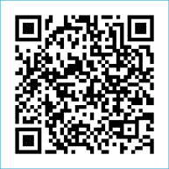
Scan to Donate

ST MARY’S PARISH NEWSLETTER - TARBERT
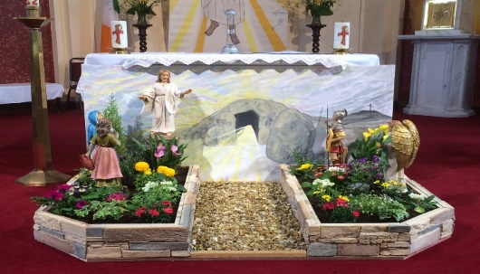
Parish Office Opening Hours:
Mon. 10.30am -2.30pm. Wed. 10.30am-1.30pm Priests :
Fri. 10.30am-2.30pm Phone ; 068-36111. Fr. Sean Hanafin 087-8341083

Email: tarbert@dioceseofkerry.ie Fr. Michael Hussey 087-2386084
Notices for Parish Newsletter have to be in on Safeguarding Children: 087-6362780 Wednesday by 12 Noon. Defib. Emergency No. 999 or 112
Webpage: www.stmarystarbert.com (Outside Surgery Hours)

Easter Sunday 31st March 2024

R.I.P. Anna Mai Hanrahan (née Hanrahan), Shrone.
Day/Date | Time | Intention
Saturday 30th | 6pm | Celebration of the Easter Vigil.  People of the Parish.
Sunday 31st | 11.30am | Easter Day of the Lord’s Resurrection.  Private Intention.
Monday 1st | 10am | Mass in Tarbert.  Thomas Dillane, Doonard Upper. ( 1st Anniversary )
Tuesday 2nd | _____ | No Mass.
Wednesday 3rd | _____ | No Mass.
Thursday 4th | ____ | No Mass.
Friday 5th | _____ | No Mass.
Saturday 6th | 6pm | Joan and Pat Brennan, St. Patrick’s Tce.  Thomas, Tommy and Mary Lyndon, Kilpadogue.
Sunday 7th | 11.30am | Joan and Jimmy Moore, Ballinoe.
PRIEST ON DUTY THIS WEEKEND: Fr. Anthony O’ Sullivan 087-2461749.
PARISH OFFERTORY COLLECTION Amount received will be published at the end of each month.
GRAVES – Families are asked to ensure that their graves are clean and tidy and to remove any unwanted items.
LIVE SERVICES – All Masses are now being live streamed from our Church. Just go to the Church website – www.stmarystarbert.com and you can watch on your phone, tablet, computer or smart T.V. When you log in and see the picture of the Altar, just underneath this, click on the mute button and you will then have the audio as well.

A very happy Easter to everyone
from Fr. Michael, Fr. Séan, Fr. Martin,
Fr. John and Fr. Philip.
Easter Holy Water

By special arrangement small bottles of Easter Holy Water will be available for collection at the Church over Easter. When visiting the Church, please use the sanitiser provided on entering and leaving.

Easter Greeting

May the resurrection of Jesus inflame our hearts with new hope.
May the risen Lord fill our hearts with joy and make us courageous heralds of his Gospel.
And may the peace of God who brought Jesus back from the dead be with us all.

TARBERT ACTIVE RETIREMENT GROUP – (over 55’s) meet in Tarbert Bridewell every Friday between 10.30am and 12 Noon. We have different activities every week followed by refreshments. New Members are welcome.
NATIONAL APOSTOLATE OF EUCHARISTIC ADORATION - Annual Pilgrimage to Knock Shrine takes place this year on the weekend of Saturday and Sunday 13th/14th April. Coach leaving Killarney at 7am on Sunday Morning. For more details contact Breda on 087-6742306 or Catherine on 087-9282421.
ALONE - the organisation that enables older people age at home are looking for Telephone and Visitation Volunteers to support older people in the community. Call 0801 222024 please or see ALONE.ie/Volunteer for more info.
LISTEN IN TO RADIO MARIA IRELAND - this coming Thursday morning Deacon Thady O'Connor will be in conversation with Margaret Carmody chairperson of the Kerry Diocesan Eucharistic Committee.RMI is on Saorview 210 on your TV or on the App Breakfast Show at 8.30 am.

DIOCESAN YOUTH PILGRIMAGE TO TAIZÉ, FRANCE - Interested in coming to Taizé this June? The diocese will be taking a group of young adults on this amazing pilgrimage from Sunday, June 23rd to Sunday June 30th 2024. Please contact Tomás Kenny for more information on 086-3683778 or email Tomás at tomaskenny@dioceseofkerry.ie
PILGRIMAGE TO MEDJUGORJE – An invitation to join us on Pilgrimage to Medjugorje on June 26th. Flights ex Cork with Aer Lingus. Spiritual Directors Fr. Danny Broderick and Fr. Joe Begley. Come and experience the Peace and Joy of Medjugorje and be renewed in our faith in the presence of Our Blessed Mother. Both Pilgrimages on May 15th and September 11th are fully booked out. For further information contact Tom Dennehy on 087-6468658.

THANK YOU - for your continuing support and financial donations that underpin the smooth running of St. Mary’s Parish Church. Please continue to donate what you can on a weekly basis at any of our Masses on Friday, Saturday, Sunday or Monday. Donations can also be made by bank transfer – our bank details are as follows :
IBAN No- IE76 AIBK 9354 3380 3050 83, Account Name – Tarbert Church Account,
Bank - AIB, The Square, Listowel Co. Kerry.
Thanking you on behalf of the Finance Committee,
John McMonagle (Chairperson), Fr. Sean Hanafin, Mary Holland, Kitty Kelly, Amanda O’Sullivan,
Seamus Enright, Declan Downey, Gabriel McNamara.

