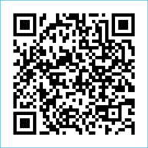
Scan to Donate

ST MARY’S PARISH NEWSLETTER - TARBERT

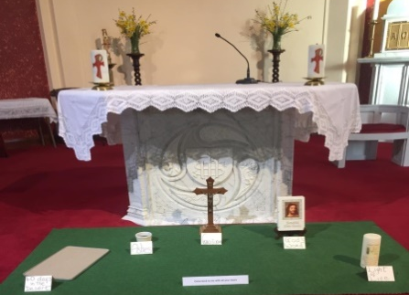
Parish Office Opening Hours:
Mon. 10.30am -2.30pm. Wed. 10.30am-1.30pm Priests :
Fri. 10.30am-2.30pm Phone ; 068-36111. Fr. Sean Hanafin 087-8341083

Email: tarbert@dioceseofkerry.ie Fr. Michael Hussey 087-2386084
Notices for Parish Newsletter have to be in on Safeguarding Children: 087-6362780 Wednesday by 12 Noon. Defib. Emergency No. 999 or 112
Webpage: www.stmarystarbert.com (Outside Surgery Hours)

First Sunday of Lent, 18th February 2024

R.I.P. Jim Mackessy, Birmingham.
Day/Date | Time | Intention
Saturday 17th | 6pm | Irene Lavelle, Canada. ( Months Mind )
Sunday 18th | 11.30am | Deceased Walsh Family Members, Kilpadogue.
Monday 19th | 10am | Mass in Tarbert.  Private Intention.
Tuesday 20th | 7pm | Mass in Ballylongford.
Wednesday 21st | 11.30am | No Mass.
Thursday 22nd | 10am | Mass in Asdee.
Friday 23rd | 7pm | Mass in Tarbert.  Nora Sheehan and Deceased Sheehan Family, Tarmons.
Saturday 24th | 6pm | Thomas Mulvihill, Woodview Place.
Sunday 25th | 11.30am | Bríd O’ Connor, Tarbert Island.  Jackie and Nuala Egan, Tarmons East and  Jack and Bernadette Dowling, Tarbert.
PRIEST ON DUTY THIS WEEKEND: Fr. Brendan Carmody 087-9601549.
PARISH OFFERTORY COLLECTION Amount received will be published at the end of each month.
LENT – has arrived now – What are we doing for Lent ?
LIVE SERVICES – All Masses are now being live streamed from our Church. Just go to the Church website – www.stmarystarbert.com and you can watch on your phone, tablet, computer or smart T.V. When you log in and see the picture of the Altar, just underneath this, click on the mute button and you will then have the audio as well.

All our Masses at St. Mary’s Church, Tarbert
can be viewed online at www.stmarystarbert.com
Prayer For Lent

Bless me heavenly Father
forgive my erring ways.
Grant me the strength to serve Thee
put purpose in my days.
Give me understanding
enough to make me kind.
So I may judge all people
with my heart and not my mind.

Teach me to be patient
in everything I do.
Content to trust your wisdom
and to follow after You.
Help me when I falter
and hear me when I pray
and receive me in Thy kingdom
to dwell with Thee someday.

Reflection for Lent

Fasting is the soul of prayer,
mercy is the lifeblood of fasting.
So if you pray, fast ; if you fast, show mercy,
if you want your petition to be heard,
hear the petition of others.
If you do not close your ear to others,
you open God’s ear to yourself. St. Peter Chrysologus.

SHANNONSIDE WOMEN’S GROUP – are meeting next Tuesday 20th Feb. at 3pm in the Community Centre. New members welcome.

TARBERT ACTIVE RETIREMENT GROUP – (over 55’s) meet in Tarbert Bridewell every Friday between 10.30am and 12 Noon. We have different activities every week followed by refreshments. New Members are welcome.
POKER CLASSIC – 5 Card Draw – in Carmody’s Bar on Friday 8th March at 8pm, entry €30. A donation will be made to the Tarbert Comprehensive ladies football teams, towards jersey’s etc. Your support would be greatly appreciated.
WEBINAR: PLANNING FOR THE FUTURE OF PARISHES - Date: Monday, February 12th at 7pm.
During this webinar, speakers from Austria and England will discuss lay involvement in their parishes. They will share the initiatives undertaken in their parishes, what has worked well, what has been challenging and what they see as the hope for the future. This webinar is in preparation for the upcoming parish gathering as part of the diocesan planning process, Moving Forward in Hope. Go to www.dioceseofkerry.ie to register.

FIRST HOLY COMMUNION - The diocese of Kerry - will host a webinar, First Holy Communion – Journeying with your Child, on Wednesday 21st February for all parents and guardians of children preparing for First Communion. The guest speaker is Dr. Patricia Kieran, parent and lecturer at Mary Immaculate College, Limerick. Register for the webinar on www.dioceseofkerry.ie

THANK YOU - for your continuing support and financial donations that underpin the smooth running of St. Mary’s Parish Church. Please continue to donate what you can on a weekly basis at any of our Masses on Friday, Saturday, Sunday or Monday. Donations can also be made by bank transfer – our bank details are as follows :
IBAN No- IE76 AIBK 9354 3380 3050 83, Account Name – Tarbert Church Account,
Bank - AIB, The Square, Listowel Co. Kerry.

