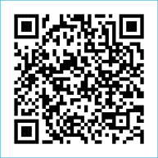
Scan to Donate

ST MARY’S PARISH NEWSLETTER - TARBERT
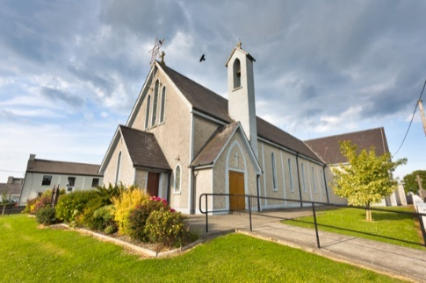
Parish Office Opening Hours:
Mon. 10.30am -2.30pm. Wed. 10.30am-1.30pm Priests :
Fri. 10.30am-2.30pm Phone ; 068-36111. Fr. Sean Hanafin 087-8341083

Email: tarbert@dioceseofkerry.ie Fr. Michael Hussey 087-2386084
Notices for Parish Newsletter have to be in on Safeguarding Children: 087-6362780 Wednesday by 12 Noon. Defib. Emergency No. 999 or 112
Webpage: www.stmarystarbert.com (Outside Surgery Hours)

Third Sunday in Ordinary Time, 21st January 2024
Sunday of the Word of God
Catholic Schools Week begins today

R.I.P. Ann Wallace (née Foley), Glin. Caroline Curtis (née Kissane), England.
Irene Lavelle (née Sylvia Bleau), Canada.
Day/Date | Time | Intention
Saturday 20th | 6pm | Billy Holly, Tarmons Hill.  Diana, Jack and Bridget Lyons, Chapel St.
Sunday 21st | 11.30am | Tommy and Seán Donovan, Tieraclea.  William, Mary and Margaret McSweeney, Kilpadogue.
Monday 22nd | 10am | Mass in Tarbert.  National School Mass.
Tuesday 23rd | 7pm | Mass in Ballylongford.
Wednesday 24th | ______ | No Mass.
Thursday 25th | 10am | Mass in Asdee.
Friday 26th | 7pm | Mass in Tarbert.  Special Intention.
Saturday 27th | 6pm | Paddy, Ger and Marion Griffin, St. Patrick;s Tce. & Cork.
Sunday 28th | 11.30am | Eileen Holly, Woodlands.
PRIEST ON DUTY THIS WEEKEND: Fr. Seán Hanafin 087-8341083.
PARISH OFFERTORY COLLECTION Amount received will be published at the end of each month.
LIVE SERVICES – All Masses are now being live streamed from our Church. Just go to the Church website – www.stmarystarbert.com and you can watch on your phone, tablet, computer or smart T.V. When you log in and see the picture of the Altar, just underneath this, click on the mute button and you will then have the audio as well.

All our Masses at St. Mary’s Church, Tarbert can be viewed online at www.stmarystarbert.com
Reflection

The most important thing about each of us
is the capacity for goodness.
We can be a source of light.
We have hands that can care,
eyes that can see,
ears that can hear,
tongues that can speak,
feet that can walk
and above all hearts that can love.
Unfortunately, through laziness, selfishness
and cowardice, our light can be dimmed,
so that we become shadows of the people we could be.
Lord, help us to believe in our own goodness
and let the light of that goodness shine.
On seeing this light others find their way
and you will be glorified.

CHURCH ENVELOPES - All the boxes of Church envelopes have now been delivered around the Parish, if there is anyone who did not get a box and would like to have one, you may call the Parish Office on 068-36111 during office hours and James will arrange to have one delivered to you.

DIOCESAN MISSION 2024 - The diocesan mission, Hope Alive!, will take place from Sunday Jan 21st – Wednesday Jan 24th. Each day, you are invited to join in the Mission Talk, Prayer, Mass, Prayer Petition and Family Time. Speakers include Adi Roche, Dr Michael Conway, Dr Keith Gaynor and Mellett. To participate in the Mission, register through the diocesan website, www.dioceseofkerry.ie

DIOCESAN EUCHARISTIC ADORATION COMMITTEE - will be holding their monthly meeting in the Parish meeting room St. Mary’s Church Listowel on Thursday 25th Jan. at 7.30pm, covering the Parishes of the Pastoral areas of Listowel and North Kerry. The committee would very much appreciate representative from each Parish of: Listowel , Lixnaw/Rathea/Irremore, Duagh/Lyreacrompane, Moyvane/Knockanure, Tarbert, Ballylongford/Asdee, Ballybunion, Ballydonoghue, with a view to establishing Adoration and getting Adorer’s back to the numbers before Covid. Deacon Thady O’Connor will be in attendance as our Chaplain. “Jesus said” Could you not Come and Watch one Hour with ME.” Info from: Margaret 087-2976304 or Maureen 087-9514352.

TARBERT ACTIVE RETIREMENT GROUP – (over 55’s) meet in Tarbert Bridewell every Friday between 10.30am and 12 Noon. We have different activities every week followed by refreshments. New Members are welcome.

DR. HELENA MOORE - Consultant Neurologist and Clinical Director at the Bons Secours Hospital, Tralee will give a one hour presentation followed by a Q & A session in The Meadowlands Hotel, Tralee from 6.30pm to 8pm on Thursday, 25th January. This is a free event open to people affected by Parkinson's, their friends, families and wider community.

THANK YOU - for your continuing support and financial donations that underpin the smooth running of St. Mary’s Parish Church. Please continue to donate what you can on a weekly basis at any of our Masses on Friday, Saturday, Sunday or Monday. Donations can also be made by bank transfer – our bank details are as follows :
IBAN No- IE76 AIBK 9354 3380 3050 83, Account Name – Tarbert Church Account,
Bank - AIB, The Square, Listowel Co. Kerry.

