St Michael’s Church Allihies/Cahermore Parish
Mass Schedule January 2024

Every Thurs evening @ 7pm Cahermore: Every Friday evening @ 6.30pm Allihies Every second Sunday Cahermore @10.00am: Every second Saturday Allihies @ 6.30pm.
Fr. John Kerin may be contacted on 086-1918246
Please pray for all those who died recently, we remember Daisy O’Sullivan Counlough , who died during the week, and those whose anniversaries occur at this time.
Mass Intentions for Weekend 6th & 7th Jan 2024 The Epiphany of The Lord.
January
Thursday | 04th Jan | Cahermore | Julia O’Sullivan – Batt, Cahermore, who died recently in London
Friday | 05th Jan | Allihies | Mass for the people of the Parish
Sunday | 07th Jan | Cahermore | Mass for the people of the Parish

Mass Intentions for Weekend 13th & 14th Jan 2024. 2nd Sunday in Ordinary time.
December
Thursday | 11th Jan | Cahermore | Timothy & Katie O’Sullivan, Billerough, remembering their daughter Margaret
Friday | 12th Jan | Allihies | Mass for the people of the Parish
Saturday | 13th Jan | Allihies | Michael O’Sullivan, Allihies & London 1st Anniversary

*** 2nd Collection Weekend 13th Jan for the Needs of the Holy Land ***
Eucharist Adoration at Cahermore Church at 6pm every Thursday.
Please contact Claire at the parish office to book Mass, Weddings, or Christenings, on 086-8344354 or email allihies@dioceseofkerry.ie Parish Office Opening Hours Tues & Thurs 2pm to 6pm
If you have any items for the parish bulletin, please email it to the parish office the Tues before you want it included.

First Friday Calls: If you or anyone you might know would like Fr John to include you in his First Friday Calls, please contact the parish office 086-8344354 during office hours.
Notices: If you would like to be part of the Allihies Parish WhatsApp group, please forward me your name and phone number. It will be a means of communication with the people of the parish if there are any late changes or cancellation to mass services. Please note this message service will be on WhatsApp only and we can work together to inform people that may not have this App.

We welcome to our faith community Baby Tessa Morris, Cluin, Allihies who was christened last weekend. God Bless her and her family.

Allihies Parish Church Envelopes: Thank you all for your kind donations in the past year, we are in the process of getting our new envelopes out, many of you may have got them at mass anyone who hasn’t received theirs and wishes to get the envelopes please contact Claire during office hours and we will arrange. Please also note everyone has a new number this year, this is a GDPR requirement, and we also have a new envelope color, it’s very important that you discard any old envelopes that you may have at home and continue with the new envelopes. Many Thanks & Best wishes for the New Year.

Beara West Family Resource Century General Support: From January 8th, 2024, our doors will once again be open to support anyone in our community who needs assistance with issues such as financial or housing worries, challenging family situations, completing lengthy application forms for entitlements, and sourcing information or the right services for you and your family. We offer a friendly welcome and confidential one-to-one meetings when required. Low-cost counselling can also be arranged with local counsellors. Phone the Centre at 027 70998 or call into us in the New Year.
Diocesan Mission 2024 The diocesan mission, Hope Alive! will take place from Sunday Jan 21st – Wednesday Jan 24th. Each day, you are invited to join in the Mission Talk, Prayer, Mass, Prayer Petition and Family Time. Speakers include Adi Roche, Dr Michael Conway, Dr Keith Gaynor and Mellett. To participate in the Mission, register through the diocesan website, www.dioceseofkerry.ie

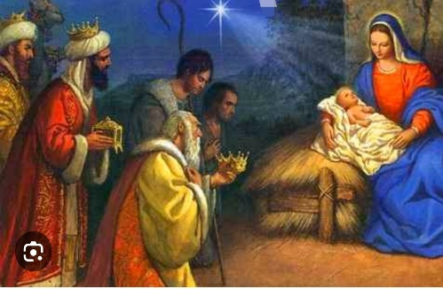
Prayer for the Epiphany:
Three wonders mark this day we celebrate:
today the star led the Magi to the manger;
today water was changed into wine at the marriage feast; today Christ desired to be baptised by John in the river Jordan to bring us salvation, alleluia.
(Magnificat antiphon of Evening Prayer)

