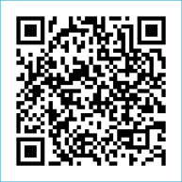
Scan to Donate

ST MARY’S PARISH NEWSLETTER - TARBERT
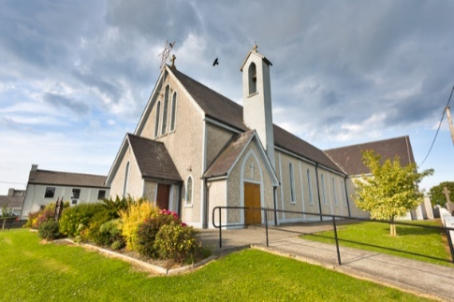
Parish Office Opening Hours:
Mon. 10.30am -2.30pm. Wed. 10.30am-1.30pm Priests :
Fri. 10.30am-2.30pm Phone ; 068-36111. Fr. Sean Hanafin 087-8341083

Email: tarbert@dioceseofkerry.ie Fr. Michael Hussey 087-2386084
Notices for Parish Newsletter have to be in on Safeguarding Children: 087-6362780 Wednesday by 12 Noon. Defib. Emergency No. 999 or 112
Webpage: www.stmarystarbert.com (Outside Surgery Hours)

Fourth Sunday in Ordinary Time,
28th January 2024

R.I.P. Frank Blake, Dublin / Carrigaholt. Marlene Mc Shane ( née Connolly ) Strabane.
Day/Date | Time | Intention
Saturday 27th | 6pm | Paddy, Ger and Marion Griffin, St. Patrick’s Tce. / Cork.
Sunday 28th | 11.30am | Eileen Holly, Woodlands.
Monday 29th | 10am | Mass in Tarbert.  Tim and Kathleen Finucane, Chapel St.
Tuesday 30th | 7pm | Mass in Ballylongford.
Wednesday 31st | ______ | No Mass.
Thursday 1st | 10am | Mass in Asdee.
Friday 2nd | 7pm | Mass in Tarbert.  Denis and Margaret O’ Driscoll, Clare.
Saturday 3rd | 6pm | John and Patrick Carrig and  Deceased Family Members, St. Patrick;s Tce.
Sunday 4th | 11.30am | Daniel (Dan) Kiely, Church St. / NewYork.  Eileen Guerin, Middleton and  Frances O’ Hanlon, Milton Keynes.
PRIEST ON DUTY THIS WEEKEND: Fr. Michael Hussey 087-2386084.
PARISH OFFERTORY COLLECTION Amount received will be published at the end of each month.
LIVE SERVICES – All Masses are now being live streamed from our Church. Just go to the Church website – www.stmarystarbert.com and you can watch on your phone, tablet, computer or smart T.V. When you log in and see the picture of the Altar, just underneath this, click on the mute button and you will then have the audio as well.

All our Masses at St. Mary’s Church,
Tarbert can be viewed online at www.stmarystarbert.com
Reflection

Grant O Lord, that each day
before we enter the little death of sleep,
we may undergo the little judgement of the past day,
so that every wrong deed may be forgiven
and every unholy thought set right.
Let nothing go down into the depths of our being,
which has not been forgiven and sanctified.
Then we shall be ready
for our final birth into eternity
and look forward with love and hope
to standing before you,
who art both judge and saviour,
holy judge and loving saviour.

CHURCH ENVELOPES - All the boxes of Church envelopes have now been delivered around the Parish, if there is anyone who did not get a box and would like to have one, you may call the Parish Office on 068-36111 during office hours and James will arrange to have one delivered to you.

TARBERT ACTIVE RETIREMENT GROUP – (over 55’s) meet in Tarbert Bridewell every Friday between 10.30am and 12 Noon. We have different activities every week followed by refreshments. New Members are welcome.
MUSIC WORKSHOP FOR LENT AND EASTER - The Diocese will host two music workshops for Lent and Easter 2024. The purpose of the workshop will be to introduce new music for both liturgical seasons. On Wednesday, 7th February, the workshop will take place in the John Paul II Pastoral Centre, Killarney at 7.30pm. On Thursday, 8th Feb. the workshop will be repeated in St John’s Parish Centre, Tralee, also at 7:30pm. The two workshops are to facilitate musicians from both north and south of the diocese. All choir directors, choir members, musicians, cantors and all involved in music ministry are welcome to attend. Music will be provided on the night. Please contact Tomás Kenny on 086 3683778 or email Tomás at tomaskenny@dioceseofkerry.ie if you’d like to attend.

VACANCIES - in the Tarbert CE Scheme; 1. Heritage / Coffee Shop Assistant – Tarbert Bridewell. Job Ref #CES-2317277
2. Parish Hall Caretaker – Community Centre Tarbert. Job Ref # CES-2317286. No experience is needed for any of these positions as full training will be provided to the successful candidate. Please apply for any of these positions by contacting Jackie on 086-3266991 or email jackiekissane@asdeeballylongfordces.ie - CE Scheme rates apply.

VOLUNTEERING - As we begin a new year, why not consider becoming a Trócaire Parish Volunteer and help make a difference in some of our world's most vulnerable communities. If you care about social and global justice, this could be for you. Activities include supporting the annual Lenten Campaign as well as taking part in a wide range of events to help Trócaire spread the word about the vital work they do. For more information, call Fr. Joe Begley on 086-2498967 or Janet Twomey on 021-4275622 or email volunteering@trocaire.org.

THANK YOU - for your continuing support and financial donations that underpin the smooth running of St. Mary’s Parish Church. Please continue to donate what you can on a weekly basis at any of our Masses on Friday, Saturday, Sunday or Monday. Donations can also be made by bank transfer – our bank details are as follows :
IBAN No- IE76 AIBK 9354 3380 3050 83, Account Name – Tarbert Church Account,
Bank - AIB, The Square, Listowel Co. Kerry.
Thanking you on behalf of the Finance Committee,
John McMonagle (Chairperson), Fr. Sean Hanafin, Mary Holland, Kitty Kelly, Amanda O’Sullivan,
Seamus Enright, Declan Downey, Gabriel McNamara and Paddy Creedon.

