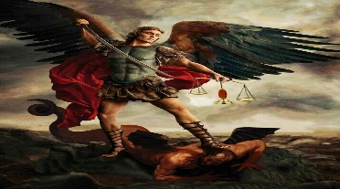
St Michael’s Church Allihies/Cahermore Parish
Mass Schedule Dec 23/Jan 24

Every Thurs evening @ 7pm Cahermore: Every Friday evening @ 6.30pm Allihies Every second Sunday Cahermore @10.00am: Every second Saturday Allihies @ 6.30pm.
Fr. John Kerin may be contacted on 086-1918246
Please pray for all those who died recently, we especially remember Monica Polly, Cahermore, who died during the week, and those whose anniversaries occur at this time.
Mass Intentions for Weekend 23rd & 24th Dec 2023. Fourth Sunday of Advent.
December
Thursday | 21st Dec | Cahermore | Mary & John O’Driscoll, Baby Martha Mullins Killaugh, Remembering Jerh & Fintan O’Driscoll Castletownbere  Confessions after Mass in Cahermore
Friday | 22nd Dec |  | Mass at Cahermore NS at 10.30am
Sunday | 24th Dec | Cahermore | Mass for the People of the Parish
Sunday | 24th Dec Christmas EVE  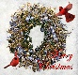  This Photo by Unknown Author is licensed under CC BY | Allihies 5.30PM | Mass for the People of the Parish  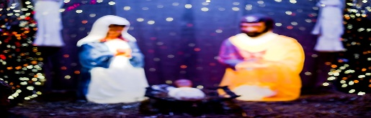
Monday | 25th Dec Christmas Day | Cahermore 10.00am | Mass for the people of the Parish  This Photo by Unknown Author is licensed under CC BY-NC
2nd Collection Christmas Eve & Christmas Day.
Mass Intentions for Weekend 30th & 31st Dec 2023. Feast of the Holy Family.
December
Thursday | 28th Dec | Cahermore | NO MASS
Friday | 29th Dec | Allihies | NO MASS
Saturday | 30th Dec | Allihies | Margaret & Donal Hanley Lichbarrahan. Remembering their sons Michael & Donal

Mass Intentions for Weekend 6th & 7th Jan 2024 The Epiphany of The Lord.
January
Thursday | 04th Jan | Cahermore | Julia O’Sullivan – Batt, Cahermore, who died recently in London
Friday | 05th Jan | Allihies | Mass for the people of the Parish
Sunday | 07th Jan | Cahermore | Mass for the people of the Parish

Please contact Claire at the parish office to book Mass, Weddings, or Christenings, on 086-8344354 or email allihies@dioceseofkerry.ie Parish Office Re Open’s Thurs 04th Jan 2024 10am - 2pm.
Priests’ Offering: ‘Christmas Offering’ The Christmas Offering Collection (which supports your priest) will be taken up at all Masses in the parish on Christmas Eve and Christmas Day. You can return your Christmas Offering envelope in this collection if you have not already done so. The Christmas Offering envelope and collection, at the Christmas masses, forms part of the five envelopes that provide for the priests’ income. No part of the Sunday collection is used for this purpose. We are extremely grateful for your continued support throughout the year.

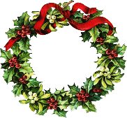
A Note from Fr John

Céad Mile Fáilte. A very warm welcome to all of you who are joining us for our Christmas Liturgies. In particular a special Welcome to those of you who are living away from home and who are back with your families for Christmas.
As we celebrate another Christmas, Lord help us to live each moment gratefully. May we have the faith to trust in the gifts you have given us. May we have the hope that overcomes the dark thoughts that sometimes cloud out vision. May we have the love that makes our world a better place. We make this prayer through Jesus, our brother, born for us again in Bethlehem. Amen. Nollaig Shona. Fr John Kerin

A Prayer for Christmas & The New Year
Dear Lord, please give me...
A few friends who understand me and remain my friends;
A work to do which has real value, without which the world would be the poorer;
A mind unafraid to travel, even though the trail be not blazed;
An understanding heart;
A sense of humour;
Time for quiet, silent meditation;
A feeling of the presence of God;
The patience to wait for the coming of these things,
With the wisdom to recognise them when they come.

