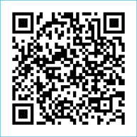
Scan to Donate

ST MARY’S PARISH NEWSLETTER - TARBERT

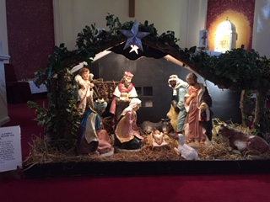
Parish Office Opening Hours:
Mon. 10.30am -2.30pm. Wed. 10.30am-1.30pm Priests :
Fri. 10.30am-2.30pm Phone ; 068-36111. Fr. Sean Hanafin 087-8341083

Email: tarbert@dioceseofkerry.ie Fr. Michael Hussey 087-2386084
Notices for Parish Newsletter have to be in on Safeguarding Children: 087-6362780 Wednesday by 12 Noon. Defib. Emergency No. 999 or 112
Webpage: www.stmarystarbert.com (Outside Surgery Hours)

Sunday 24th December 2023

The Vigil of the Nativity

Day/Date | Time | Intention
Saturday 23rd | 6pm | Adam Crowley, Galway. ( 1st Anniversary )  John Branagan, Dooncaha.
Sunday 24th | 6pm | Christmas Eve Mass in Tarbert.  The Vigil of the Nativity.
Monday 25th | 11.30am | Christmas Day Mass in Tarbert.  The Nativity of our Lord Jesus Christ.
Tuesday 26th | _____ | No Mass.
Wednesday 27th | ______ | No Mass.
Thursday 28th | _____ | No Mass.
Friday 29th | _____ | No Mass.
Saturday 30th | 6pm | Elizabeth Kissane, St. Patrick’s Tce.  Der O’ Connor, Ballinoe.  Henry and Margaret O’ Donnell, The Square.  Dan and Kathleen O’ Connor, Tieraclea.
Sunday 31st | 11.30am | Eileen Steel, Kilpadogue. ( 1st Anniversary )  Irene, Tommy and Michael Brassil, Shanaway.

PRIEST ON DUTY THIS WEEKEND: Fr. Brendan Carmody 087-9601549.
PARISH OFFERTORY COLLECTION Amount received will be published at the end of each month.
LIVE SERVICES – All Masses are now being live streamed from our Church. Just go to the Church website – www.stmarystarbert.com and you can watch on your phone, tablet, computer or smart T.V. When you log in and see the picture of the Altar, just underneath this, click on the mute button and you will then have the audio as well.

CHRISTMAS CEREMONIES
In the North Kerry Pastoral Area 2023

Saturday 23rd December Asdee @ 6pm
Ballybunion @ 7pm
Ballydonoghue @ 7.30pm
Ballylongford @ 7pm
Tarbert @ 6pm

Christmas Eve Asdee @ 8pm
Ballybunion @ 7pm
Ballybunion @ 9pm
Ballydonoghue @ 7.30pm
Ballylongford @ 7pm
Tarbert @ 6pm

Christmas Day Asdee @ 9.30am
Ballybunion @ 11.30am
Ballydonoghue @ 11am
Ballylongford @ 10.30am
Tarbert @ 11.30am

CHRISTMAS BLESSINGS TO YOU

Fr. Michael, Fr. Seán
Fr. John, Fr. Martin and Fr. Philip
take this opportunity to wish you
a Happy, Peaceful and Safe Christmas.

May the blessings of the Divine Child and the love of
His Holy Mother be yours now and forever.

