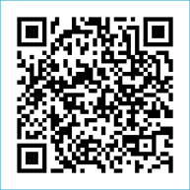
Scan to Donate

ST MARY’S PARISH NEWSLETTER - TARBERT
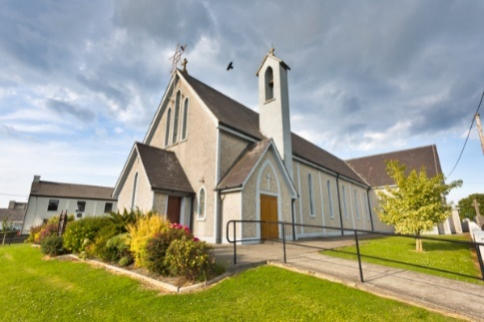
Parish Office Opening Hours:
Mon. 10.30am -2.30pm. Wed. 10.30am-1.30pm Priests :
Fri. 10.30am-2.30pm Phone ; 068-36111. Fr. Sean Hanafin 087-8341083

Email: tarbert@dioceseofkerry.ie Fr. Michael Hussey 087-2386084
Notices for Parish Newsletter have to be in on Safeguarding Children: 087-6362780 Wednesday by 12 Noon. Defib. Emergency No. 999 or 112
Webpage: www.stmarystarbert.com (Outside Surgery Hours)

30th Sunday in Ordinary Time 29th October 2023

R.I.P. Michael Sweeney, Nottingham / Tarmons. Fr. Tim O’ Connor, Manister.
Day/Date | Time | Intention
Saturday 28th | 6pm | Danny and Mai Finucane, Doonard Lower.
Sunday 29th | 11.30am | Sadie and Eddie O’ Connor and  Deceased Family Members, Glencullare.  Patrick ( Pakie ) Lyons, Chapel St.
Monday 30th | _______ | No Mass.
Tuesday 31st | 7pm | Mass in Ballylongford.
Wednesday 1st  All Saints | 6pm | Mass in Tarbert.  Holy Day.
Thursday 2nd  All Souls Day. | 6pm | Mass in Tarbert.  The Commemoration of All The Faithful Departed.
Friday 3rd | 7pm | Mass in Tarbert.  James and Esther McNamara and  Deceased Family Members, Tieraclea.
Saturday 4th | 6pm | Johnny and Joan Mackessy, Ballyline.  John Coleman, Chapel St.
Sunday 5th | 11.30am | Bridgie, Donal and Maurice Boland, Kilpadogue.

PRIEST ON DUTY THIS WEEKEND: Fr. Brendan Carmody 087-9601549.
PARISH OFFERTORY COLLECTION Amount received will be published at the end of each month.
TIME CHANGE – Summer time ends this weekend. Please remember clocks fall back one hour on Saturday night.
ANNUAL REMEMBRANCE MASS – for all who have died during the year, will be celebrated on Friday 10th Nov. at 7pm.
DIOCESAN COLLECTION – A special diocesan collection for the Irish Church Commission and Agencies will be held next weekend Sat. 4th / Sun. 5th Nov. You can use one of the Special Collection envelopes for it.
LIVE SERVICES – All Masses are now being live streamed from our Church. Just go to the Church website – www.stmarystarbert.com and you can watch on your phone, tablet, computer or smart T.V. When you log in and see the picture of the Altar, just underneath this, click on the mute button and you will then have the audio as well.
A Prayer for the Synod in Rome

Holy Spirit, breath of Pentecost, you send us to proclaim Christ and to welcome into our communities those who do not yet know him. Come down, we pray, upon the participants of the Synod and upon all who are present in this church, filling them with your wisdom and courage in order to be servants of communion and bold witnesses of your forgiveness in today’s world! We make this prayer through Christ our Lord, Amen.

Prayer for our Deceased

Grant them
eternal rest
O’ Lord and let
perpetual light
shine upon
them.

TARBERT BINGO – The committee have decided to host monthly Bingo on the first Wed. of each month at the new time of 8pm. Prizes will be in line with attendance. Your support would be greatly appreciated. All are welcome.
TARBERT ACTIVE RETIREMENT GROUP – (over 55’s) meet in Tarbert Bridewell every Friday between 10.30am and 12 Noon. We have different activities every week followed by refreshments. New Members are welcome.
TARBERT N.S. - are now accepting enrolments for September 2024. If you wish to enrol a child who will be four on or before August 31st 2024 a copy of the school’s Annual Admission Notice, Admission Policy and the Application Form for Admission for 2023/2024 are available to download at: tarbertns.scoilnet.ie/blog , on request: By emailing office@tarbertns.ie or writing to: Tarbert N.S., Chapel St., Tarbert, Listowel, Co. Kerry. V31 TW13. Completed forms to be returned by November 20th 2023.

THANK YOU - for your continuing support and financial donations that underpin the smooth running of St. Mary’s Parish Church. Please continue to donate what you can on a weekly basis at any of our Masses on Friday, Saturday, Sunday or Monday. Donations can also be made by bank transfer – our bank details are as follows :
IBAN No- IE76 AIBK 9354 3380 3050 83, Account Name – Tarbert Church Account,
Priest’s Account – IBAN No – IE66 AIBK 9354 3380 3051 66, Account Name – Fraternal Account,
Bank - AIB, The Square, Listowel, Co. Kerry.
Thanking you on behalf of the Finance Committee,
John McMonagle (Chairperson), Fr. Sean Hanafin, Mary Holland, Kitty Kelly, Amanda O’Sullivan,
Seamus Enright, Declan Downey, Gabriel McNamara and Paddy Creedon.

