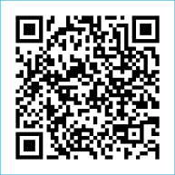
Scan to Donate

ST MARY’S PARISH NEWSLETTER - TARBERT
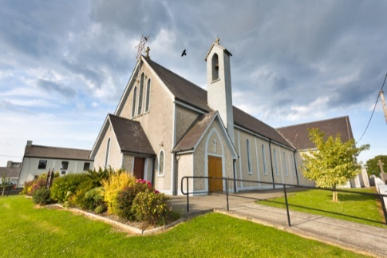
Parish Office Opening Hours:
Mon. 10.30am -2.30pm. Wed. 10.30am-1.30pm Priests :
Fri. 10.30am-2.30pm Phone ; 068-36111. Fr. Sean Hanafin 087-8341083

Email: tarbert@dioceseofkerry.ie Fr. Michael Hussey 087-2386084
Notices for Parish Newsletter have to be in on Safeguarding Children: 087-6362780 Wednesday by 12 Noon. Defib. Emergency No. 999 or 112
Webpage: www.stmarystarbert.com (Outside Surgery Hours)

29th Sunday in Ordinary Time 22nd October 2023
Mission Sunday

Day/Date | Time | Intention
Saturday 21st | 6pm | Paddy, Ger and Marion Griffin, St. Patrick’s Tce. / Cork.  William (Willie) Buckley, Ballyculhane / Chapel St.  ( Months Mind )
Sunday 22nd | 11.30am | Finbarr, John and Patrick Carrig, St. Patrick’s Tce.
Monday 23rd | 10am | Mass in Tarbert.  Special Intention.
Tuesday 24th | 7pm | Mass in Tarbert.  Comprehensive School, 1st Year Mass.
Wednesday 25th | _______ | No Mass.
Thursday 26th | 10am | Mass in Asdee.
Friday 27th | 7pm | Mass in Tarbert.  Private Intention.
Saturday 28th | 6pm | Danny and Mai Finucane, Doonard Lower.
Sunday 29th | 11.30am | Sadie and Eddie O’ Connor and  Deceased Family Members, Glencullare.  Patrick (Pakie) Lyons, Chapel St.
PRIEST ON DUTY THIS WEEKEND: Fr. Declan O’ Connor 087-0908949.
PARISH OFFERTORY COLLECTION Amount received will be published at the end of each month.
DIOCESAN COLLECTION – A special diocesan collection for Mission Sunday will be held this weekend Sat. 21st / Sun. 22nd Oct. You can use one of the Special Collection envelopes for it.
LIVE SERVICES – All Masses are now being live streamed from our Church. Just go to the Church website – www.stmarystarbert.com and you can watch on your phone, tablet, computer or smart T.V. When you log in and see the picture of the Altar, just underneath this, click on the mute button and you will then have the audio as well.

All our Masses at St. Mary’s Church, Tarbert, can be viewed online at www.stmarystarbert.com
A Prayer for the Synod in Rome

Holy Spirit, breath of Pentecost, you send us to proclaim Christ and to welcome into our communities those who do not yet know him. Come down, we pray, upon the participants of the Synod and upon all who are present in this church, filling them with your wisdom and courage in order to be servants of communion and bold witnesses of your forgiveness in today’s world! We make this prayer through Christ our Lord, Amen.

THIS SUNDAY IS WORLD MISSION SUNDAY
October is designated as Mission month. There are approximately 1,300 Irish born missionaries working in more than 80 countries around the world. During this month we unite ourselves in prayer with them and the communities with whom they serve. A special collection will be held this weekend.

TARBERT BINGO – The committee have decided to host monthly Bingo on the first Wed. of each month at the new time of 8pm. Prizes will be in line with attendance. Your support would be greatly appreciated. All are welcome.
TARBERT ACTIVE RETIREMENT GROUP – (over 55’s) meet in Tarbert Bridewell every Friday between 10.30am and 12 Noon. We have different activities every week followed by refreshments. New Members are welcome.
CLOTHES COLLECTION – The Shannonside Women’s Group will hold a clothes collection in the Church car park on next Thursday 26th October from 8am to 10.30am. Bags can also be dropped into the Community Centre on Wednesday evening between 6pm and 7pm. The proceeds are in aid of the Milford Hospice.
PART TIME COURSE - Do you want to improve your Literacy Skills for Everyday Living? Kerry Education and Training Board adult part-time courses will be starting shortly in Listowel. For more information contact Mary on 086-7969627. All part-time courses are free of charge.
INVITATION TO MEDJUGORJE MASS - People who have been on pilgrimage to Medjugorje or who are thinking of going there, are invited to Sunday Mass in the Sacred Heart Church, Milltown on Sunday October 29th at 11:15am. All are welcome.
THANK YOU – The Finance Committee would like to acknowledge the receipt of a $1,000 donation to our Church from Andy Carmody of New York, they are most grateful for this generous gesture.

THANK YOU - for your continuing support and financial donations that underpin the smooth running of St. Mary’s Parish Church. Please continue to donate what you can on a weekly basis at any of our Masses on Friday, Saturday, Sunday or Monday. Donations can also be made by bank transfer – our bank details are as follows :
IBAN No- IE76 AIBK 9354 3380 3050 83, Account Name – Tarbert Church Account,
Priest’s Account – IBAN No – IE66 AIBK 9354 3380 3051 66, Account Name – Fraternal Account,
Bank - AIB, The Square, Listowel, Co. Kerry.
Thanking you on behalf of the Finance Committee,
John McMonagle (Chairperson), Fr. Sean Hanafin, Mary Holland, Kitty Kelly, Amanda O’Sullivan,
Seamus Enright, Declan Downey, Gabriel McNamara and Paddy Creedon.

