Allihies/Cahermore Parish
Mass Schedule September
Every Thurs evening @ 7pm Cahermore: Every Friday evening @ 6.30pm Allihies
Every second Sunday Cahermore @10.00am: Every second Saturday Allihies @ 6.30pm
Fr. John Kerin may be contacted on 086-1918246
Please pray for all those who died recently, and those whose anniversaries occur at this time.
Mass Intentions for Weekend 30 Sept – 01st Oct 2023 26th Sunday in Ordinary time.
Sept
Thursday | 28th Sept | Cahermore | Mass for the People of the Parish
Friday | 29th Sept | Allihies | *Pete Rua Harrington 50th Anniversary, Ballydonegan, remembering his wife Rita & the deceased Harrington family members.  *Margaret McMahon, The Strand & Leixlip
Sunday | 01st Oct | Cahermore | Harvest Thanksgiving Mass

Mass Intentions for Weekend 07th & 08th October 2023. 27th Sunday in Ordinary time.
September
Thursday | 05th Oct | Cahermore | No Intention
Friday | 06th Oct | Allihies | Mass for the People of the Parish
Saturday | 07th Oct | Allihies | Anthony O’Sullivan, Gortahig, and remembering the deceased members of the O’Sullivan Family

Eucharist Adoration at Cahermore Church at 6pm every Thursday.
If anyone wishes to book mass, christenings or weddings please call.
Claire 086-8344354 or email allihies@dioceseofkerry.ie 2pm– 6pm Tue and Thurs,
Any items for the parish bulletin, please email it to allihies@dioceseofkerry.ie, the Tues before you want it included.
First Friday Calls: If you or anyone you might know would like Fr John to include you in his First Friday Calls, please contact the parish office 086-8344354 during office hours.
Notices: If you would like to be part of the Allihies Parish WhatsApp group, please forward me your name and phone number. It will be a means of communication with the people of the parish if there are any late changes or cancellation to mass services. Please note this message service will be on WhatsApp only and we can work together to inform people that may not have this App. Please see our new Facebook page Allihies Cahermore Parish feel free to add this page.
Allihies Echoes 2023: Anybody interested in submitting an article, poem, photo or anything else - please do so to allihiesechoes@gmail.com or by hand to John Terry's. Latest date for submissions is Saturday 14th October.
Allihies Community Care: we are restarting our group with a gathering in O’Neill’s Bar on Tues 03rd Oct. We look forward to welcoming Parishioners. If you are interested, please contact Mary Patricia Sullivan. More Details TBA is Saturday 14th October.
Prayer for the Synod: There will be a time of ecumenical prayer and reflection to mark the opening (in Rome) of the Synod on Synodality at St John’s Church, Castle Street, Tralee. Saturday 30th September 3pm to 4pm. All welcome.
Communal first Saturday: The Communal First Saturday devotions will take place on the 7th of October starting at 8.45 am in the Church of the Resurrection Killarney Devotions will begin with the Fatima intentions followed by the Rosary and the celebration of Mass at 9.30am. All will be done with the intention of saving souls and making reparation to the Immaculate Heart of Mary, thus fulfilling Our Lady's request to the Laity to pray for peace.
Feast of St Michael
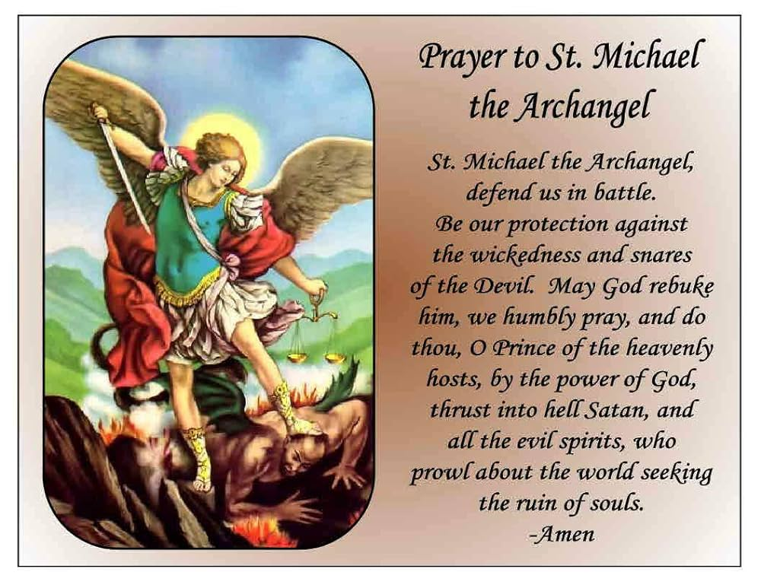
St Michael is the patron saint of our parish and 2 churches, and we remember him on his feast day 29th September.
St Michael Pray For Us

