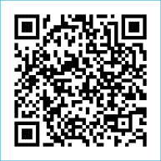
Scan to Donate

ST MARY’S PARISH NEWSLETTER - TARBERT
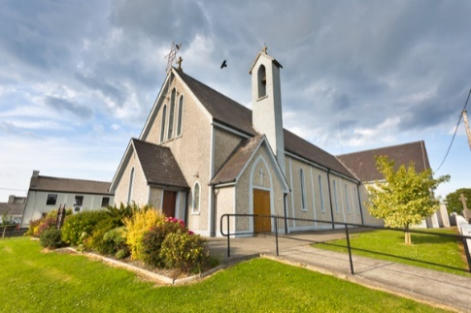
Parish Office Opening Hours:
Mon. 10.30am -2.30pm. Wed. 10.30am-1.30pm Priests :
Fri. 10.30am-2.30pm Phone ; 068-36111. Fr. Sean Hanafin 087-8341083

Email: tarbert@dioceseofkerry.ie Fr. Michael Hussey 087-2386084
Notices for Parish Newsletter have to be in on Safeguarding Children: 087-6362780 Wednesday by 12 Noon. Defib. Emergency No. 999 or 112
Webpage: www.stmarystarbert.com (Outside Surgery Hours)

24th Sunday in Ordinary Time 17th September 2023

R.I.P. Sr. Sheila Collins, Ballygoughlin / U.S.A. Denis McCarthy, Tarbert / Dublin.
Day/Date | Time | Intention
Saturday 16th | 6pm | Tim, Mai and Tom Mahony, Kilcolgan.
Sunday 17th | 11.30am | Patrick and Mary Normile, Dooncaha and  Margaret, John, Tony and Edward Courtney and  Deceased Wallace Family Members, Tarmons.
Monday 18th | 10am | Mass in Tarbert.  Thanksgiving Mass.
Tuesday 19th | 7pm | Mass in Ballylongford.
Wednesday 20th | _______ | No Mass.
Thursday 21st | 10am | Mass in Asdee.
Friday 22nd | 7pm | Mass in Tarbert.  Special Intention.
Saturday 23rd | 6pm | Brendan and Maureen Cregan, Tieraclea.
Sunday 24th | 11.30am | Jane Kiely, Main St. ( 1st Anniversary )  Seán Ferris, Glencullare.
PRIEST ON DUTY THIS WEEKEND: Fr. Pat Crean-Lynch 087-2200114.
PARISH OFFERTORY COLLECTION Amount received will be published at the end of each month.
HAPPY BIRTHDAY – Fr. Philip celebrates another year this weekend, we wish him well and hope that he has a lovely day.
LIVE SERVICES – All Masses are now being live streamed from our Church. Just go to the Church website – www.stmarystarbert.com and you can watch on your phone, tablet, computer or smart T.V. When you log in and see the picture of the Altar, just underneath this, click on the mute button and you will then have the audio as well.

All our Masses at St. Mary’s Church, Tarbert, can be viewed online at www.stmarystarbert.com
Prayer for our Earth

All powerful God,
You are present in the universe
and in the smallest of your creatures.
You embrace with your tenderness all that exists.
Pour out upon us the power of Your love,
that we may protect life and beauty.
Fill us with Your peace, that we may live
as brothers and sisters, harming no one. Amen.

TARBERT ACTIVE RETIREMENT GROUP – (over 55’s) meet in Tarbert Bridewell every Friday between 10.30am and 12 Noon. We have different activities every week followed by refreshments. New Members are welcome.
COFFEE MORNING - in aid of the Swanky Cathy Fundraiser is this Friday 15th of Sept. from 10.30am - 2.30pm in Tarbert Bridewell.

THE SWANKY CATHY FUNDRAISER NIGHT - will be held at the Swanky Bar in Tarbert, Saturday 30th September at 9pm. Auction of a Greyhound Pup on the night is kindly sponsored by the Saleen Kennels. A Monster Raffle will also take place on the night with 1st Prize of a Flat Screen T.V. and numerous other prizes. Tickets €10 or 6 for €50 are available from all local businesses and committee members.

The Totus Tuus Men - for Christ Conference 2023 - a Catholic Conference for men will be LIVE & EXCLUSIVE on Radio Maria Ireland this Saturday 16th September from 2pm. Speakers at this years conference are - Fr. Billy Swan, Fr. Chris Hayden, Anthony Crossey and Fr. John Harris OP.

WORKSHOP FOR THOSE POST CANCER TREATMENT - Recovery Haven Kerry is delighted to facilitate a wonderful patient education workshop “Laces”on Sept. 25th from 11am to 1.30pm for adults who are post cancer treatment. Jointly created by the National Cancer Control Programme (NCCP) and the Irish Cancer Society (ICS), the workshop aims to bridge the gap in services between the end of active treatment and potentially, suitable longer-term support. The Life and Cancer – Enhancing Survivorship (LACES) workshop is for adult patients who have finished their active cancer treatment and are beginning their long-term follow up. This includes patients who are post-surgery, radiation therapy, the acute phase of their chemotherapy treatment and patients with advanced cancer, who have discontinued treatment or who are receiving ongoing treatment. The workshop will focus on Food and Drink, Finance, Work and Family Life; Confidence Body Image & Intimacy; Self-Management and Supports Near You.
To register call 066-7192122 or email patienteducation@irishcancer.ie

THANK YOU - for your continuing support and financial donations that underpin the smooth running of St. Mary’s Parish Church. Please continue to donate what you can on a weekly basis at any of our Masses on Friday, Saturday, Sunday or Monday. Donations can also be made by bank transfer – our bank details are as follows :
IBAN No- IE76 AIBK 9354 3380 3050 83, Account Name – Tarbert Church Account,
Priest’s Account – IBAN No – IE66 AIBK 9354 3380 3051 66, Account Name – Fraternal Account,
Bank - AIB, The Square, Listowel, Co. Kerry.
Thanking you on behalf of the Finance Committee,
John McMonagle (Chairperson), Fr. Sean Hanafin, Mary Holland, Kitty Kelly, Amanda O’Sullivan,
Seamus Enright, Declan Downey, Gabriel McNamara and Paddy Creedon.

