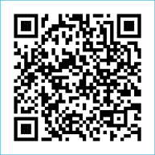
Scan to Donate

ST MARY’S PARISH NEWSLETTER - TARBERT
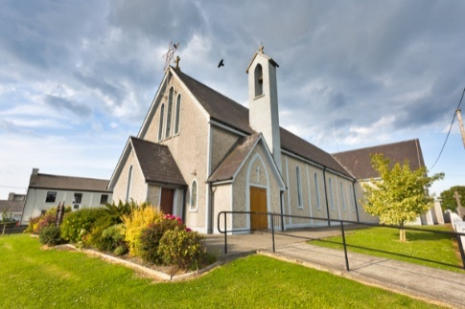
Parish Office Opening Hours:
Mon. 10.30am -2.30pm. Wed. 10.30am-1.30pm Priests :
Fri. 10.30am-2.30pm Phone ; 068-36111. Fr. Sean Hanafin 087-8341083

Email: tarbert@dioceseofkerry.ie Fr. Michael Hussey 087-2386084
Notices for Parish Newsletter have to be in on Safeguarding Children: 087-6362780 Wednesday by 12 Noon. Defib. Emergency No. 999 or 112
Webpage: www.stmarystarbert.com (Outside Surgery Hours)

23rd Sunday in Ordinary Time 10th September 2023
World Mental Health Day

Day/Date | Time | Intention
Saturday 9th | 6pm | Anna Marie McGibney and Deceased McGibney and  Keane Families, Tieraclea Park.  Ena Stibbs ( née Finucane ),  Piermount / England. ( Months Mind )
Sunday 10th | 11.30am | Theresa Mackessy, London. ( 1st Anniversary )  Dan Snr., Tessie and Deceased Kiely Family Members,  Main St.
Monday 11th | ______ | No Mass.
Tuesday 12th | ______ | No Mass.
Wednesday 13th | _______ | No Mass.
Thursday 14th | ______ | No Mass.
Friday 15th | 7pm | Mass in Tarbert.  Private Intention.
Saturday 16th | 6pm | Tim, Mai and Tom Mahony, Kilcolgan.
Sunday 17th | 11.30am | Patrick and Mary Normile, Dooncaha and  Margaret, John, Tony and Edward Courtney and Deceased Wallace Family Members, Tarmons.

PRIEST ON DUTY THIS WEEKEND: Fr. Denis O’ Mahony 087-6807197.
PARISH OFFERTORY COLLECTION Amount received will be published at the end of each month.
LIVE SERVICES – All Masses are now being live streamed from our Church. Just go to the Church website – www.stmarystarbert.com and you can watch on your phone, tablet, computer or smart T.V. When you log in and see the picture of the Altar, just underneath this, click on the mute button and you will then have the audio as well.

All our Masses at St. Mary’s Church, Tarbert, can be viewed online at www.stmarystarbert.com
Prayer for Mental Health

O Lord our God,
for those of us whose lives are strained and stressed ….
Hear our prayer and pour out your peace.

For those of us whose hold on life is fragile ….
Hear our prayer and pour out your peace.

For those of us whose illness makes them vulnerable ….
Hear our prayer and pour out your peace.

For those of us whose families struggle to understand them ….
Hear our prayer and pour out your peace.

For families and friends, nurses, doctors and therapists and
all who seek to walk alongside the stressed and strained,
the vulnerable and the fragile ….
Hear our prayer and pour out your peace. Amen.

TARBERT ACTIVE RETIREMENT GROUP – (over 55’s) meet in Tarbert Bridewell every Friday between 10.30am and 12 Noon. We have different activities every week followed by refreshments. New Members are welcome.
COFFEE MORNING - in aid of the Swanky Cathy Fundraiser is next Friday 15th of Sept. from 10.30am - 2.30pm in Tarbert Bridewell.

NEW ADULT CHOIR - Mary Culloty O’ Sullivan is starting a brand new Adult Choir in North Kerry. Come along and register your interest and hear all about classes, fees, etc. Classes will begin on Monday 11th September from 1pm to 2.30pm. All are welcome.

THE SWANKY CATHY FUNDRAISER NIGHT - will be held at the Swanky Bar in Tarbert, Saturday 30th September at 9pm. Auction of a Greyhound Pup on the night is kindly sponsored by the Saleen Kennels. A Monster Raffle will also take place on the night with 1st Prize of a Flat Screen T.V. and numerous other prizes. Tickets €10 or 6 for €50 are available from all local businesses and committee members.

The Totus Tuus Men - for Christ Conference 2023 - a Catholic Conference for men will be LIVE & EXCLUSIVE on Radio Maria Ireland Saturday 16th September from 2pm. Speakers at this years conference are - Fr. Billy Swan, Fr. Chris Hayden, Anthony Crossey and Fr. John Harris OP.

THANK YOU - for your continuing support and financial donations that underpin the smooth running of St. Mary’s Parish Church. Please continue to donate what you can on a weekly basis at any of our Masses on Friday, Saturday, Sunday or Monday. Donations can also be made by bank transfer – our bank details are as follows :
IBAN No- IE76 AIBK 9354 3380 3050 83, Account Name – Tarbert Church Account,
Priest’s Account – IBAN No – IE66 AIBK 9354 3380 3051 66, Account Name – Fraternal Account,
Bank - AIB, The Square, Listowel, Co. Kerry.
Thanking you on behalf of the Finance Committee,
John McMonagle (Chairperson), Fr. Sean Hanafin, Mary Holland, Kitty Kelly, Amanda O’Sullivan,
Seamus Enright, Declan Downey, Gabriel McNamara and Paddy Creedon.

