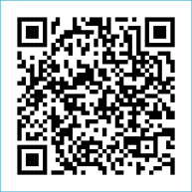
Scan to Donate

ST MARY’S PARISH NEWSLETTER - TARBERT
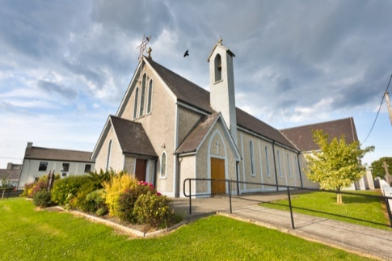
Parish Office Opening Hours:
Mon. 10.30am -2.30pm. Wed. 10.30am-1.30pm Priests :
Fri. 10.30am-2.30pm Phone ; 068-36111. Fr. Sean Hanafin 087-8341083

Email: tarbert@dioceseofkerry.ie Fr. Michael Hussey 087-2386084
Notices for Parish Newsletter have to be in on Safeguarding Children: 087-6362780 Wednesday by 12 Noon. Defib. Emergency No. 999 or 112
Webpage: www.stmarystarbert.com (Outside Surgery Hours)

The Most Holy Body and Blood of Christ
Sunday 11th June 2023
R.I.P. Henry Scanlon, U.S.A. / Tarbert.
Day/Date | Time | Intention
Saturday 10th | 6pm | Bertie Costelloe, Doonasrd Crescent.  John Joe and Peggy Barrett, Tarmons.
Sunday 11th | 11.30am | Mary O’ Carroll, Pulleen. ( Months Mind )  John (Johnny) Coolahan, Dublin / Main St.  Padraig (Paudie) Dillane, Chicago / Chapel St.
Monday 12th | 10am | Mass in Tarbert.  Tadgh and Liam Foley, Doonard Lower / Tieraclea.
Tuesday 13th | 7pm | Mass in Ballylongford.
Wednesday 14th | ______ | No Mass.
Thursday 15th | 10am | Mass in Asdee.
Friday 16th | 7pm | Mass in Tarbert.  Mary Hennessy / Marie Mc Carthy, Main St.
Saturday 17th | 6pm | Deceased O’ Connell Family Members, Dooncaha.  Nancy and Jimmy Enright, Tieraclea.
Sunday 18th | 11.30am | Maureen Cregan, Tieraclea. ( Months Mind )  Fr. Tommy O’ Hanlon, Dooncaha.
PRIEST ON DUTY THIS WEEKEND: Fr. Seán Hanafin 087-8341083.
PARISH OFFERTORY COLLECTION Amount received will be published at the end of each month.
THE NOVENA TO THE SACRED HEART – began on Thursday 8th June and continues until Friday 16th June.
LIVE SERVICES – All Masses are now being live streamed from our Church. Just go to the Church website – www.stmarystarbert.com and you can watch on your phone, tablet, computer or smart T.V. When you log in and see the picture of the Altar, just underneath this, click on the mute button and you will then have the audio as well.

All our Masses at St. Mary’s Church, Tarbert,
can be viewed online at www.stmarystarbert.com
Sacred Heart Novena

Lord Jesus Christ your heart was moved with love for those who sought You.
You healed the sick, fed the hungry and forgave sinners.
You showed to those who would listen the way to true life,
for You are the Way, the Truth and the Life.
Your heart is still moved today by your people and their needs.
Open my heart to hear your word, to accept your love and to respond to your call.
In particular, I beg you to grant me the favour that I ask
during this Novena, (make your request silently)
provided that it will contribute to my own eternal good
and to the building up of your Kingdom of love, peace and justice here on earth.
Most Sacred Heart of Jesus, I place all my trust in You.

TARBERT BINGO – The committee have decided to host monthly Bingo on the first Wed. of each month at the new time of 8pm. Prizes will be in line with attendance. Your support would be greatly appreciated. All are welcome.

TARBERT ACTIVE RETIREMENT GROUP – (over 55’s) meet in Tarbert Bridewell every Friday between 10.30am and 12 Noon. We have different activities every week followed by refreshments. New Members are welcome.
CLOTHING COLLECTION - Tarbert National School are having a clothing collection on next Friday 16th June. We are appealing for 1 x 10kg bag per household. Bags can be dropped at the school and will be stored. As always your support is greatly appreciated.
Thank you, Tarbert National School.

ANNUAL PILGRIMAGE TO KNOCK – is on Wednesday 5th July. The bus will leave from The Square at 7.30am, anyone interested in travelling please contact Nuala Carmody on 068-36116.

JOIN ACCORD - and train as a Marriage Preparation Programme Facilitator. If you have a positive attitude towards marriage in the Catholic Church. If you have the enthusiasm to be part of the ACCORD team in supporting couples who are preparing for the sacrament of Marriage. Please contact Aisling on 01-5053112 or email: marriagepreparation@accord.ie

KERRY DIOCESAN PILGRIMAGE TO LOURDES - will take place from Sept. 1st to the 6th and will be led by Bishop Ray.
Flights will be from Kerry Airport and bookings can be made through Marian Pilgrimages Dublin. Phone 01-8788159.

THANK YOU - for your continuing support and financial donations that underpin the smooth running of St. Mary’s Parish Church. Please continue to donate what you can on a weekly basis at any of our Masses on Friday, Saturday, Sunday or Monday. Donations can also be made by bank transfer – our bank details are as follows :
IBAN No- IE76 AIBK 9354 3380 3050 83, Account Name – Tarbert Church Account,
Priest’s Account – IBAN No – IE66 AIBK 9354 3380 3051 66, Account Name – Fraternal Account,
Bank - AIB, The Square, Listowel, Co. Kerry.
Thanking you on behalf of the Finance Committee,
John McMonagle (Chairperson), Fr. Sean Hanafin, Mary Holland, Kitty Kelly, Amanda O’Sullivan,
Seamus Enright, Declan Downey, Gabriel McNamara and Paddy Creedon.

