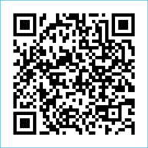
Scan to Donate

ST MARY’S PARISH NEWSLETTER - TARBERT
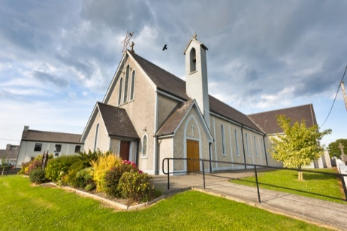
Parish Office Opening Hours:
Mon. 10.30am -2.30pm. Wed. 10.30am-1.30pm Priests :
Fri. 10.30am-2.30pm Phone ; 068-36111. Fr. Sean Hanafin 087-8341083

Email: tarbert@dioceseofkerry.ie Fr. Michael Hussey 087-2386084
Notices for Parish Newsletter have to be in on Safeguarding Children: 087-6362780 Wednesday by 12 Noon. Defib. Emergency No. 999 or 112
Webpage: www.stmarystarbert.com (Outside Surgery Hours)

11th Sunday in Ordinary Time
18th June 2023

R.I.P. Annie Panayi ( née Pattwell ), Strabane / Tarbert.
Day/Date | Time | Intention
Saturday 17th | 6pm | Deceased O’ Connell Family Members, Dooncaha.  Nancy and Jimmy Enright, Tieraclea.
Sunday 18th | 11.30am | Maureen Cregan, Tieraclea. ( Months Mind )  Fr. Tommy O’ Hanlon, Dooncaha.
Monday 19th | 10am | Mass in Tarbert.  Private Intention.
Tuesday 20th | 7pm | Mass in Ballylongford.
Wednesday 21st | ______ | No Mass.
Thursday 22nd | 10am | Mass in Asdee.
Friday 23rd | 7pm | Mass in Tarbert.  Peggy and Johnny Stack, Kilpadogue.
Saturday 24th | 6pm | Donal, Bridgie and Maurice Boland, Kilpadogue.
Sunday 25th | 11.30am | James Murphy, Church St. ( 1st Anniversary )
PRIEST ON DUTY THIS WEEKEND: Fr. Michael Hussey 087-2386084.
PARISH OFFERTORY COLLECTION Amount received will be published at the end of each month.
LIVE SERVICES – All Masses are now being live streamed from our Church. Just go to the Church website – www.stmarystarbert.com and you can watch on your phone, tablet, computer or smart T.V. When you log in and see the picture of the Altar, just underneath this, click on the mute button and you will then have the audio as well.

All our Masses at St. Mary’s Church, Tarbert,
can be viewed online at www.stmarystarbert.com
Exam Prayer

Dear Lord, as I take these exams,
I thank you that my life is
enfolded in the embrace on
Your great love for me.
Help me with all the testing
challenges of life that will
come my way.

Holy Spirit, guide me with the
gifts of Wisdom, Knowledge,
Understanding and right Judgement.

Holy Mary, pray for us
and all our young people.
May they know the touch of
your loving caress. Amen.

TARBERT BINGO – The committee have decided to host monthly Bingo on the first Wed. of each month at the new time of 8pm. Prizes will be in line with attendance. Your support would be greatly appreciated. All are welcome.

TARBERT ACTIVE RETIREMENT GROUP – (over 55’s) meet in Tarbert Bridewell every Friday between 10.30am and 12 Noon. We have different activities every week followed by refreshments. New Members are welcome.
ANNUAL PILGRIMAGE TO KNOCK – is on Wednesday 5th July. The bus will leave from The Square at 7.30am, anyone interested in travelling please contact Nuala Carmody on 068-36116.

JOIN ACCORD - and train as a Marriage Preparation Programme Facilitator. If you have a positive attitude towards marriage in the Catholic Church. If you have the enthusiasm to be part of the ACCORD team in supporting couples who are preparing for the sacrament of Marriage. Please contact Aisling on 01-5053112 or email: marriagepreparation@accord.ie

KERRY DIOCESAN PILGRIMAGE TO LOURDES - will take place from Sept. 1st to the 6th and will be led by Bishop Ray.
Flights will be from Kerry Airport and bookings can be made through Marian Pilgrimages Dublin. Phone 01-8788159.

THANK YOU - for your continuing support and financial donations that underpin the smooth running of St. Mary’s Parish Church. Please continue to donate what you can on a weekly basis at any of our Masses on Friday, Saturday, Sunday or Monday. Donations can also be made by bank transfer – our bank details are as follows :
IBAN No- IE76 AIBK 9354 3380 3050 83, Account Name – Tarbert Church Account,
Priest’s Account – IBAN No – IE66 AIBK 9354 3380 3051 66, Account Name – Fraternal Account,
Bank - AIB, The Square, Listowel, Co. Kerry.
Thanking you on behalf of the Finance Committee,
John McMonagle (Chairperson), Fr. Sean Hanafin, Mary Holland, Kitty Kelly, Amanda O’Sullivan,
Seamus Enright, Declan Downey, Gabriel McNamara and Paddy Creedon.

