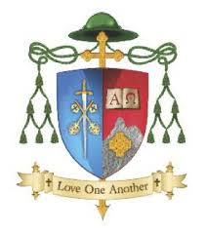

Diocese of Kerry
Vacancy for Diocesan Advisor for Primary Religious Education
Full Name
Address for Correspondence
Home Telephone Number
Mobile Number
Email Address

Please list details of Experience / Employment History to date (in chronological order):

From - To | Employer and Location | Description of Key Responsibilities
Please list details of relevant achievements to date:

Please list details of Qualifications/Education/Continued Professional Development to date:

Full title Degree(s) / Qualifications held (indicate undergraduate or postgraduate) | Description / Duration of course (FT, PT, seminar, etc.) | Subject(s) in final exam | University, College or Examining Authority | Year

Hobbies and interests:

Personal References (name, occupation, phone number and address of two referees)

________________________________ ____________________
Signature Date
Please specify what other experience, involvements and/or special qualities you have which you feel equip you for the position of Diocesan Advisor for Primary Religious Education.

Completed application form and cover letter by email, in confidence,
Quoting Subject: “Diocesan Advisor for Primary Religious Education” to:

diocesanpastoralcentre@dioceseofkerry.org

Closing date for applications is 5 pm on Friday June 16st 2022

Short listing will apply. Canvassing will disqualify.

The Diocese of Kerry is an equal opportunity employer.

