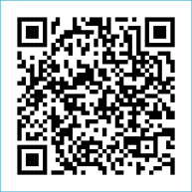
Scan to Donate

ST MARY’S PARISH NEWSLETTER - TARBERT
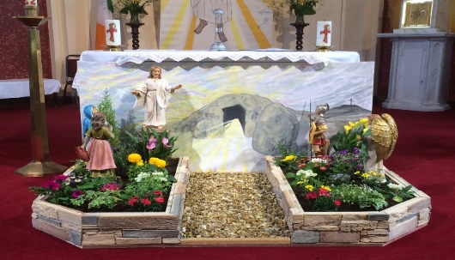
Parish Office Opening Hours:
Mon. 10.30am -2.30pm. Wed. 10.30am-1.30pm Priests :
Fri. 10.30am-2.30pm Phone ; 068-36111. Fr. Sean Hanafin 087-8341083

Email: tarbert@dioceseofkerry.ie Fr. Michael Hussey 087-2386084
Notices for Parish Newsletter have to be in on Safeguarding Children: 087-6362780 Wednesday by 12 Noon. Defib. Emergency No. 999 or 112
Webpage: www.stmarystarbert.com (Outside Surgery Hours)

Third Sunday of Easter 23rd April 2023

R.I.P. Mary O’ Carroll, Pulleen. Joan Landers (née Dore), Listowel. Marie Collins (née Buckley), Ballygoughlin.
Day/Date | Time | Intention
Saturday 22nd | 6pm | Siobhan White, Doonard Crescent.( 1st Anniversary )  Eithne Finucane, ( Months Mind ) and  Brendan and Jack Finucane, Piermount.
Sunday 23rd | 11.30am | Eddie and Bridie Healy and Deceased Family Members,  Kildare.
Monday 24th | 10am | Mass in Tarbert.  Bernard James, Dooncaha.
Tuesday 25th | 7pm | Mass in Ballylongford.
Wednesday 26th | ______ | No Mass.
Thursday 27th | 10am | Mass in Asdee.
Friday 28th | 7pm | Mass in Tarbert.  Johnny, Mikie and Martin O’ Connell, Ballydonoghue.
Saturday 29th | 6pm | Liza Mulvihill and Hannah and John Shanahan, Glin.
Sunday 30th | 11.30am | Mina Coolahan, Main St.  Special Intention.
PRIEST ON DUTY THIS WEEKEND: Fr. Seán Hanafin 087-8341083.
PARISH OFFERTORY COLLECTION Amount received will be published at the end of each month.
DIOCESAN COLLECTION – a second collection will be taken up for Peter’s Pence this weekend Sat. 22nd / Sun. 23rd April.
TRÓCAIRE – Just a reminder that the Trócaire Collection is due to be sent away. If anyone has any box or envelope for Trócaire please return it to the Sacristy or to the Parish Office. Thank you.

LIVE SERVICES – All Masses are now being live streamed from our Church. Just go to the Church website – www.stmarystarbert.com and you can watch on your phone, tablet, computer or smart T.V. When you log in and see the picture of the Altar, just underneath this, click on the mute button and you will then have the audio as well.

All our Masses at St. Mary’s Church, Tarbert can be viewed online at www.stmarystarbert.com
From The Finance Committee
· We are very pleased to confirm that we exceeded our financial breakeven target with an audited surplus of €5,990 for the year ended 31st December 2022.
· Our thanks and appreciation to all those who contribute so generously, to our service providers, to our Auditors Hannan Accounting Services and to James Lavery for his continuing dedication and hard work throughout 2022.
· Despite the cessation of the Covid Wage subsidy scheme (€15,600 in 2021) overall income figure increased from €76,937 to €82,777 (7.6%) over 2021. Operational costs also increased from €68,155 to €76,787 (13%) with a net surplus of income over expenditure of €5,990.
· Significant increases in the offertory collections (23%), maintenance (15%) Rental Income (623%) Revenue refunds (30%) are the significant positive upward trends in income.
· Scheduled increases in salary costs (due to extended hours and responsibilities) were offset by some very prudent cost management on a number of line items (including our light and heat costs which reversed national trends showing a decrease of 4% over 2021.) All invoices for the period have been processed and paid.
· A very special word of Thanks and Appreciation to the Tarbert Community Services who donated €5,000 and all donors who contributed throughout the year.
· We are pleased with the restoration of our online services earlier this year after a significant investment was required to upgrade the services.
· Challenges ahead include managing in times when energy costs remain high and the consumer price index rose by 8.5% between February 2022 and February 2023.
Signed
John McMonagle (Chairperson) Fr.Sean Hanafin, Mary Holland, Amanda O’Sullivan, Kitty Kelly, Gabriel McNamara, Seamus Enright, Declan Downey and Paddy Creedon .

