Scan to Donate

ST MARY’S PARISH NEWSLETTER - TARBERT
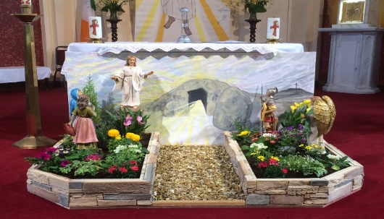
Parish Office Opening Hours:
Mon. 10.30am -2.30pm. Wed. 10.30am-1.30pm Priests :
Fri. 10.30am-2.30pm Phone ; 068-36111. Fr. Sean Hanafin 087-8341083

Email: tarbert@dioceseofkerry.ie Fr. Michael Hussey 087-2386084
Notices for Parish Newsletter have to be in on Safeguarding Children: 087-6362780 Wednesday by 12 Noon. Defib. Emergency No. 999 or 112
Webpage: www.stmarystarbert.com (Outside Surgery Hours)

Easter Sunday 9th April 2023

R.I.P. Thomas Dillane, Doonard Upper.
Day/Date | Time | Intention
Saturday 8th | 6pm | Celebration of the Easter Vigil.  People of the Parish.
Sunday 9th | 11.30am | Easter Day of the Lord’s Resurrection.  Private Intention.
Monday 10th | ______ | No Mass.
Tuesday 11th | 7pm | Mass in Ballylongford.
Wednesday 12th | ______ | No Mass.
Thursday 13th | 10am | Mass in Asdee.
Friday 14th | ______ | No Mass.
Saturday 15th | 6pm | Stephen and Noreen Lavery, Ballyline.  Nell Heffernan, Ballydonoghue.
Sunday 16th | 11.30am | Emer Ward, Doonard Crescent.  Marie Sweeney, ( Months Mind ) and  Martin Sweeney,Tarmons.
PRIEST ON DUTY THIS WEEKEND: Fr. Denis O’ Mahony 087-6807197.
PARISH OFFERTORY COLLECTION Amount received will be published at the end of each month.
LIVE SERVICES – All Masses are now being live streamed from our Church. Just go to the Church website – www.stmarystarbert.com and you can watch on your phone, tablet, computer or smart T.V. When you log in and see the picture of the Altar, just underneath this, click on the mute button and you will then have the audio as well.
A very happy Easter to everyone
from Fr. Michael, Fr. Séan, Fr. Martin,
Fr. John and Fr. Philip.

All our Masses at St. Mary’s Church, Tarbert can be viewed online at www.stmarystarbert.com
Easter Holy Water

By special arrangement small bottles of Easter Holy Water will be available for collection at the Church over Easter. When visiting the Church, please use the sanitiser provided on entering and leaving.

Easter Greeting

May the resurrection of Jesus inflame our hearts with new hope.
May the risen Lord fill our hearts with joy and make us courageous heralds of his Gospel.
And may the peace of God who brought Jesus back from the dead be with us all.

TARBERT BINGO – has started back again. The new committee have decided to host monthly Bingo on the first Wed. of each month at the new time of 8pm. Prizes will be in line with attendance. Your support would be greatly appreciated. All welcome.
TARBERT ACTIVE RETIREMENT GROUP – (over 55’s) meet in Tarbert Bridewell every Friday between 10.30am and 12 Noon. We have different activities every week followed by refreshments. New Members are welcome.
CLOTHES COLLECTION – The Shannonside Women’s Group will hold a clothes collection in the church car park on Thursday 27th April from 8am to 10.30am. The proceeds are in aid of “Darkness into Light” and Tarbert Tidy Towns.
BUÍOCHAS – Is mian le Conradh na Gaeilge buíochas a gabhaíl le gach éinne a cabhraig lus an Bailuíchán Naísuínta Lále Phádraig. Bailiódh €310. Thugadh €210 don Chonradh agus €100 do Scoil Náisuínta Thairbeart chun an Gaeilge a chur chun cinn.

THANK YOU - for your continuing support and financial donations that underpin the smooth running of St. Mary’s Parish Church. Please continue to donate what you can on a weekly basis at any of our Masses on Friday, Saturday, Sunday or Monday. Donations can also be made by bank transfer – our bank details are as follows :
IBAN No- IE76 AIBK 9354 3380 3050 83, Account Name – Tarbert Church Account,
Bank - AIB, The Square, Listowel Co. Kerry.
Thanking you on behalf of the Finance Committee,
John McMonagle (Chairperson), Fr. Sean Hanafin, Mary Holland, Kitty Kelly, Amanda O’Sullivan,
Seamus Enright, Declan Downey, Gabriel McNamara and Paddy Creedon.

