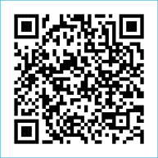
Scan to Donate

ST MARY’S PARISH NEWSLETTER - TARBERT
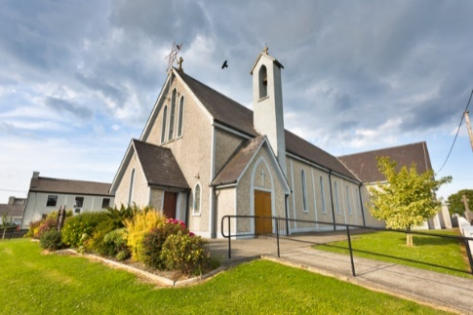
Parish Office Opening Hours:
Mon. 10.30am -2.30pm. Wed. 10.30am-1.30pm Priests :
Fri. 10.30am-2.30pm Phone ; 068-36111. Fr. Sean Hanafin 087-8341083

Email: tarbert@dioceseofkerry.ie Fr. Michael Hussey 087-2386084
Notices for Parish Newsletter have to be in on Safeguarding Children: 087-6362780 Wednesday by 12 Noon. Defib. Emergency No. 999 or 112
Webpage: www.stmarystarbert.com (Outside Surgery Hours)

Sixth Sunday in Ordinary Time 12th February 2023

R.I.P. Eileen Guerin (née Holly), Midelton / Church St. Joe Kissane, New York / Dooncaha.
Mary Foster ( née Langan ), Limerick / Tarbert Island.

Day/Date | Time | Intention
Saturday 11th | 6pm | Kathleen O’ Dowd and Margaret Sayers,  Carhoona and Colorado.
Sunday 12th | 11.30am | John Lavery, Toronto / Ivy House.  Amos, Winnie and John Murray, Chapel St.
Monday 13th | 10am | Mass in Tarbert.  Deceased Walsh Family Members, Kilpadogue.
Tuesday 14th | 7pm | Mass in Ballylongford.
Wednesday 15th | _____ | No Mass.
Thursday 16th | 10am | Mass in Asdee.
Friday 17th | 7pm | Mass in Tarbert.  Ita Gormley, Tieraclea Park. ( 1st Anniversary. )
Saturday 18th | 6pm | Jackie and Nuala Egan, Tarmons East.  Charles and Jane Ita McGibney and  Deceased Family Members, Tieraclea Park.
Sunday 19th | 11.30am | People of the Parish.
PRIEST ON DUTY THIS WEEKEND: Fr. Brendan Carmody 087-9601549.
PARISH OFFERTORY COLLECTION Amount received will be published at the end of each month.
LIVE SERVICES – All Masses are now being live streamed from our Church. Just go to the Church website – www.stmarystarbert.com and you can watch on your phone, tablet, computer or smart T.V. When you log in and see the picture of the Altar, just underneath this, click on the mute button and you will then have the audio as well.

All our Masses at St. Mary’s Church, Tarbert
can be viewed online at www.stmarystarbert.com
Reflection

There are fears that cripple us –
Of being let down, of losing the capacity to trust,
of how children will turn out, of death, illness and old age.
Of losing a job or never getting one, of failure in a college course,
of not being loved or liked.
Fear is like a red light stopping us moving forward
and it’s crippling if it gets us stuck like a light never changing to green.
Jesus answers us simply …”be not afraid”, because he is always with us.
We have the security of a constant companion.
Lord, help us to trust in your loving presence today and every day. AMEN.

CHURCH ENVELOPES - All the boxes of Church envelopes have now been delivered around the Parish, if there is anyone who did not get a box and would like to have one, you may call the Parish Office on 068-36111 during office hours and James will arrange to have one delivered to you.
TARBERT BINGO – has started back again. The committee have decided to host monthly Bingo on the first Wed. of each month at 8.30pm. Prizes will be in line with attendance. Your support would be greatly appreciated. All welcome.
TARBERT ACTIVE RETIREMENT GROUP – (over 55’s) are starting back on Feb. 3rd in Tarbert Bridewell between 10.30am and 12 Noon. We have different activities every week followed by refreshments. New Members are welcome.
LITURGY/ MUSIC WORKSHOP FOR LENT - The diocese will host two liturgy/music workshops to help parishes prepare for Lent. All those involved in liturgy, sacred spaces or music ministry are invited to attend. The workshops will take place on Monday, February 13th 7.30pm – 9pm in St. Brendan’s Parish Centre, Tralee and on Wednesday, February 15th 7.30pm – 9pm in St John Paul II Pastoral Centre, Killarney. For more information, check out www.dioceseofkerry.ie or call Tomás Kenny on 086 -3683778 or email tomaskenny@dioceseofkerry.ie

KERRY MOBILE LIBRARY – started back in The Square in Tarbert on Wed. 25th Jan. from 12.30pm to 1pm and they will be there fortnightly at the same time. The service is free of charge and a book request service is available.

THANK YOU - for your continuing support and financial donations that underpin the smooth running of St. Mary’s Parish Church. Please continue to donate what you can on a weekly basis at any of our Masses on Friday, Saturday, Sunday or Monday. Donations can also be made by bank transfer – our bank details are as follows :
IBAN No- IE76 AIBK 9354 3380 3050 83, Account Name – Tarbert Church Account,
Bank - AIB, The Square, Listowel Co. Kerry.

Thanking you on behalf of the Finance Committee,
John McMonagle (Chairperson), Fr. Sean Hanafin, Mary Holland, Kitty Kelly, Amanda O’Sullivan,
Seamus Enright, Declan Downey, Gabriel McNamara, James Lavery and Paddy Creedon.

