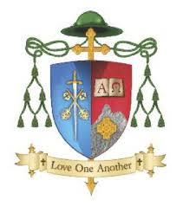

Diocese of Kerry
Vacancy for Pastoral Development Worker
Full Name
Address for Correspondence
Home Telephone Number
Mobile Number
Email Address

Please list details of Experience / Employment History to date (in chronological order):
From - To | Employer and Location | Description of Key Responsibilities

Please list details of relevant achievements to date:

Please list details of Qualifications/Education/Continued Professional Development to date:

Full title Degree(s) / Qualifications held (indicate undergraduate or postgraduate) | Description / Duration of course (FT, PT, seminar, etc.) | Subject(s) in final exam | University, College or Examining Authority | Year

Hobbies and interests:

Personal References (name, occupation, phone number and address of two referees)

________________________________ ____________________
Signature Date

Please specify what other experience, involvements and/or special qualities you have which you feel equip you for the position of Pastoral Development Worker.

Completed application form and cover letter by email, in confidence,
Quoting Subject: “Pastoral Development Worker” to:
diocesanpastoralcentre@dioceseofkerry.org

Closing date for applications is 5 pm Friday Oct 21st 2022
Short listing will apply. Canvassing will disqualify.

The Diocese of Kerry is an equal opportunity employer.

