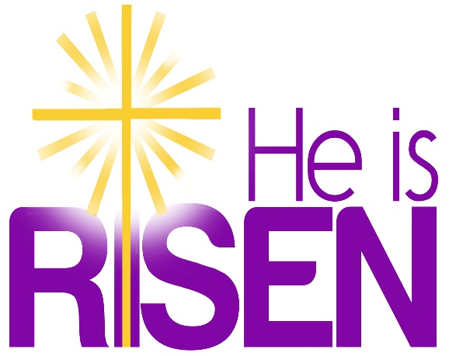

***Just a thought***

Easter does not remove the trials and crosses of life but it gives it a meaning. It lights it up with hope. All is different because Jesus is alive and speaks His words of peace to us as He spoke them to the apostles. Faith in the resurrection of Jesus is the basis of our hope of eternal life, a hope which enables us to bear patiently the trials of life. Therefore, there is a quiet joy among us and a deep sense of peace because we know that life is stronger than death.

|  |  |  |
| --- | --- | --- |
| **Easter Sunday 17/04/2022.** | | |
| Please pray for Sr. Nora Foley USA & formerely Cockhill; Eileen O’Shea nee Galvin, Killarney who died recently. May they rest in peace. | | |
| Priest on duty this weekend: Fr. Padraig Kennelly 083 3541877  (for emergencies only) | | |
| **Masses for the coming week** | | |
| **Good Friday** | **3.00pm**  **7.30pm** | Passion of the Cross  Stations of the Cross |
| **Sat 16th Apr.**  **Easter Vigil** | **9.00pm** | People of the Parish |
| **Sun 17th Apr.**  **Easter Sun.** | **11.30am** | Fr. John Lucid R.I.P. Castleisland & former Parish Priest of Kilcummin.  Bernard, Gretta & Tim O’Callaghan R.I.P.  Clashnagarrane. |
| **Tues 19thApr.** | **9.30am**  **10.00am** | Healing Mass for family intention  Adoration |
| **Thu 21st Apr** | **7.30pm** | Patrick & Eileen O’Leary R.I.P. Knocklebede |
| **Sat 23rd Apr** | **7.30pm** | Jeremiah, Margaret & Donie Mangan R.I.P. Milleen  John, Breda & Denny O’Connor & deceased family members R.I.P. Glounonea |
| **Sun 24th Apr** | **11.30am** | Seamus O’Connor R.I.P. Clyddaugh  Darren & Dan O’Sullivan R.I.P. Tournanough |

|  |  |  |
| --- | --- | --- |
| **Eucharistic**  **Ministers** | **23rd & 24th April** | **30th April & 1st May** |
| **7.30pm Vigil** | K. Fleming K. Fitzgerald | K. Fleming K. Fitzgerald |
| **11.30a.m.** | A. Murray M. O’Sullivan | A. Murray M. O’Sullivan |

**Offertory Collection:** €675.00

**Second Collection** next weekend Apr.23rd/24th is for Peter’s Pence.

**Easter Offerings Collection** for the support of the priests of the parish - Envelopes are in the boxes of envelopes & also available at the doors. We appreciate your continued generosity and assure you of our prayer for you.

**Blessings of the season:** Wishing all our parishoners and visitors a very happy Easter graced by the presence of the Risen Lord.

**Parish Office.** Open: Tues., Wed. & Fri 10.00am – 12noon. Tel: 064

6643176/Mobile: 087 1339732, e-mail [kilcummin@dioceseofkerry.ie](mailto:kilcummin@dioceseofkerry.ie)

**Lay people to take up leadership roles in the Diocese of Kerry:**

Ministry of the Lay Pastoral Leader is being introduced as a response to the changing needs of parish communities. The lay pastoral leaders will work alongside the clergy. Their role will be to lead, co-ordinate and support different aspects of parish life. If you are interested in this ministry, check out [www.dioceseofkerry.ie](http://www.dioceseofkerry.ie)

**Divine Mercy Sunday** will be celebrated in St. Mary’s Cathedral on Sunday 24th April @ 3pm, preceded by the Rosary @ 2.40pm. All welcome.

**Trócaire Boxes:** You can return your gift for Trócaire in support of the developing world over the Easter period. It would be appreciated if you could convert your donation to notes.

**Rosary at the Grottos:** The Rosary will be prayed each day during the month of May at 8pm at Glounonea Grotto and the Grotto in the Church grounds. We are praying for Ireland and for peace in the world.

**Listening Session for Pope Francis’ Invitation to Contribute to the Synod 2023** will take place at The Killarney Heights Hotel on Wed. 27th April @ 7.30pm. Following up on Pope Francis’ invitation to every member of the Church throughout the world to share their experiences, insights and hopes for the ‘Church For Synod 2023’ – Killarney Pastoral Area invite anybody from the parishes of Killarney, Kilcummin, Fossa, Firies and Glenflesk to this open meeting, giving people the opportunity for reflection, discussion and feedback in preparation for the Synod of Bishops in 2023. All welcome. Further details & info.on [www.dioceseofkerry.ie/Synod](http://www.dioceseofkerry.ie/Synod)

**Bingo:** Kilcummin Parents Association will be hosting an Easter Family Bingo in the Dromhall Hotel Killarney, Sun. 24th April @ 3pm, all welcome. Jackpot of €1,000 must go on the day. Raffle & spot prizes too.

**Cancer Support Charity** ‘**Recovery Haven Kerry’** will host a free online course for those supporting a loved one with cancer, beginning on Tue. Apr.26th with an introductory session, and will then run weekly, via Zoom from 10.30am to 1pm. Those interested can now register by phone to 0667192122 or email [siobhan@recoveryhavenkerry.com](mailto:siobhan@recoveryhavenkerry.com)

﻿**Gaelic Roots** is a traditional Irish Dance and Music show that runs at the Killarney Avenue Hotel from April until late October every year. The award winning show is a two hour spectacular showcase of traditional Irish music and contemporary and traditional Irish dance. Rated 5 stars on Trip Advisor the show caters for locals and tourists and has won many accolades and awards since its debut in April 2016.The show features a full 5 piece live band under the direction of musical director Conor Moriarty, world class Irish dancers including two time world champion Sean Slemon.

**Art Competition:** The theme for this year's Fleadh Cheoil Chiarraí art competition is **‘The Fleadh is Back!’.**The closing date is 18th May. The finished pieces can be A4 or A3 in size.There are three age categories: U9, U12 and U15. Entries to be posted to eircode V31CX89 as the pieces will be displayed in Dúchas during the two weekends of Fleadh Cheoil Chiarraí in June & the prizes will also be presented.

**Congratulations** to Caoimhe O’Halloran, Ballinamanagh who was crowned champion at the World Dancing championships in Belfast during the week.

**Kilcummin Community Games:** Kilcummin Community Games are looking to take part in the U12's boys Soccer. All participants' 12th birthday must be after 31st July 2022. Please contact Donal on 087 2581681 for more information. All participants must reside in Kilcummin.

**Easter Prayer**

Dear Lord God,

we thank You that You are a forgiving God,

who wipes out all the wrongs from the past,

and starts anew with us today.

Bring healing and comfort to those who are anxious, upset, lonely or ill today;

Encourage those who help and care for them.

May all who suffer be led from pain to peace.

We give You thanks for Your loving mercy shown to us in Jesus Christ, who endured the suffering of the cross to overcome all that separates us from You, and was raised up to new life.

Strengthen our faith in the victory of the cross and the hope of eternal life.

Help us to grow in the life which does not end,

In love and friendship with You,

Which lasts forever;

Through Your son our Saviour Jesus Christ.

Amen.

