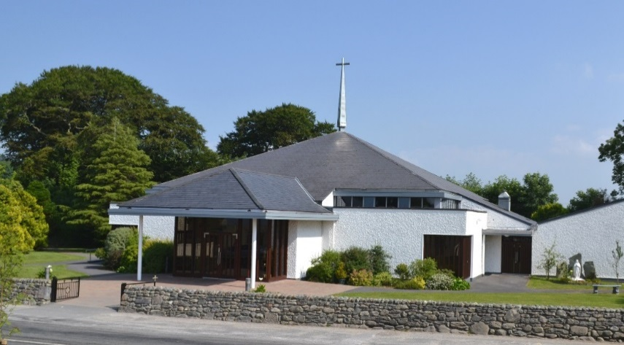
Kilcummin Parish Newsletter
Fr. Kieran O’Brien, Fr. Niall Geaney, Fr. Kevin McNamara, Fr. Padraig Kennelly, Fr. Niall Howard,
Fr. Jim Lenihan.
For a priest in an emergency at any time call
064 6631014 / mobile 087 6501998
www.kilcumminparish.com
Email: kilcummin@dioceseofkerry.ie
Priest on duty this Sunday contact
Fr. Niall Geaney 087 3888878

Just a Thought
Do we see a bit of ourselves in the man who came to Jesus? A good man who wants to find the way to eternal life. He went away sad when Jesus’ advice seemed too demanding, too frightening, too risky. Hopefully he reflected on the first reading and prayed for the Spirit of Wisdom. Maybe then he realised that God will help him to eternal life.
When have we understood for the first time how we had let ourselves be influenced by the false values of the world? May we understand that deep union with God is not a matter of being good because only God is good, nor of learning off by heart a list of things to do. Something is still lacking, - to experience God is looking deep within our souls and loving us, to feel that we could sell everything we own and distribute it to the poor, because nothing in the whole world is more important than being with Him.

28th Sunday in Ordinary Time. 10/10/2021
Priest on duty this weekend: Fr. Niall Geaney 087 3888878
Please pray for Paddy Doyle, Gneeveguilla; Creda McElligott nee Kavanagh, Ardfert who died recently. May they rest in peace.
Masses for the coming week
Sat. 9th Oct. | 7.30pm | Michael and Anne O’Riordan R.I.P. Coolick.
Sun. 10th Oct. | 11.30am | Kilcummin Historical Group – Deceased members of the Parish in the Irish War of Independence.
Tue. 12th Oct. | 9.30am  10.00am | Andrew & Kitty McCarthy R.I.P. Kilcummin Post Office.  Adoration.
Thu. 14th Oct. | 7.30pm | Con & Mary Sheahan R.I.P. Rathanane
Sat. 16th Oct. | 7.30pm | Sean & Nora (Pigott) Goss and their son Brendan R.I.P. Tralee Rd.
Sun. 17th Oct. | 11.30am | Timothy & Hannah O’Connor & deceased family members R.I.P. Glounonea

Eucharistic  Ministers | 16th & 17th October | 23rd & 24th October
7.30pm Vigil | B. Lenihan. G. Pigott.  M. O’Connor. B. Fleming. | K. Fitzgerald.  K. Fleming.
11.30a.m. | M. O’Sullivan. B. O’Sullivan. Mgt. O’Sullivan. | A. Murray. M. O’Sullivan.  G. Fleming. N. Fleming.
Offertory Collection: €860.00. A sincere thank you to all who continue to hand in your weekly envelopes, Mass offerings & all other donations.
Diocese of Kerry Mission Month Online Event: We Cannot Remain Silent ‘We cannot but speak about what we seen and heard’. Join Missionaries as they share their experience of working in Sudan and South Sudan on Oct.21st 8pm. Register online https://www.dioceseofkerry.ie further info. contact email desbailey@dioceseofkerry.ie /Tel 064 6632644.
Baptism: We would like to welcome baby Ada Therese, Bridgefield, Killarney into God’s family with joy. Congratulations to her parents Philip & Elaine and wishing them many years of health and happiness.
Parish Pastoral Council meeting next Thurs. 14th Oct. @ 8pm in the Parish Centre. Fr. Kieran O’Brien sends out a ‘Céad Míle Fáilte’ to all who would like to become members of the Parish Pastoral Council.
Parish Office. Open: Tues., Wed. & Fri 10.00am – 12noon. Webcam: www.churchservices.tv/kilcummin. Tel: 064 6643176/Mobile: 087 1339732, e-mail kilcummin@dioceseofkerry.ie
Marriage Enrichment Weekend, 5th–7thNov. This is an online experience (using Zoom), starting on Friday evening at 8pm and ending on Sunday afternoon at 2.30pm. Details at https://www.marriageencounter.ie.
Kilcummin Rural Development: The AGM of the Kilcummin Rural Development Board is provisionally booked for Wednesday 20th October @ 8pm in the Parish Office. Due to the stepping down of a number of key Directors after many years of dedicated voluntary service this is a very important meeting for the continuation of the Board and the twenty five jobs that they sponsor for the local community groups/organisations in Kilcummin and Killarney. The Board is seeking the support of all groups that avail of CE participants as well as local interested individuals to come along and support the viability and continuation of this very important Community Scheme to the Parish. Ní neart go cur le chéile.
An Invitation-Lectio Divina: Drink from your own well (St Bernard of Clairvaux) An introduction to the reading, reflection and prayer of the Gospels for anyone who seeks a way towards hope, wisdom and faith in day to day life. Presented by Fr Seamus O’ Connell on learning to pray the scriptures from your life. 3 Sessions: Mondays 18 Oct & 1st Nov 7.30pm – 9pm (zoom) and Sat.13 Nov. Tralee and Zoom. Register: Phone 087 6873208. Email office@stjohns.ie Please put ‘Lectio Divina’ in Subject line.
Kilcummin Comhaltas AGM will be held this Monday 11th Oct. at 8.30pm in the Recreational Hall. All welcome.
Kilcummin Parent & Toddler Group which was closed as a result of Covid 19, will be starting back this Mon. 11th Oct. 9.30am-11.30am. in the Recreational Hall. Parents, grandparents, minders, babies and toddlers all welcome. We need some funds to pay for insurance, rent, heating and equipment so that we can get started. This much needed service will help both parents and toddlers in the community who have suffered from isolation due to the pandemic. We are running an online fundraiser on “go fund me”. Access via the link below and see our Facebook page “Kilcummin parent and toddler group” for updates. https://gofund.me.da18089e
Kilcummin Looking Good wish to express their support for the board of Kilcummin Rural Development (KRD) in their endeavours as the main sponsor of the Community Employment (CE) scheme. The AGM of KRD is provisionally booked for Oct 20th and we would ask anyone who may be interested to attend the AGM.
Kilcummin GAA: ‘Split The Pot’ Congratulations to Gillian O’Sullivan winner of our 50/50 Split The Pot. Gillian receives €155.00. Next draw Sun. 17th October. Tickets available from Kilcummin P.O., Paddy O’Keefe’s, Gattabawn or www.kilcummingaa.com.
GAA Lotto: Next draw this Monday 11th October; Jackpot €6,750. Please support, tickets available online and in local shops.
Kilcummin play Beaufort this Sunday at 2.30 pm in Kilcummin. This is
the quarter final of the Intermediate club championship and tickets can be
purchased online. Programmes for the game are also available to download
from Kerry GAA website.

Prayer of St. Pope John XX111
(Feast Day 11th October)

O Jesus, send labourers into Your fields
which are awaiting holy apostles,
saintly priests, heroic missionaries
and dedicated sisters and brothers.
Enkindle in the hearts of men and women
the spark of vocation.
Grant that Christian families
may desire to give to Your church
helpers in the work of tomorrow.
Amen.

