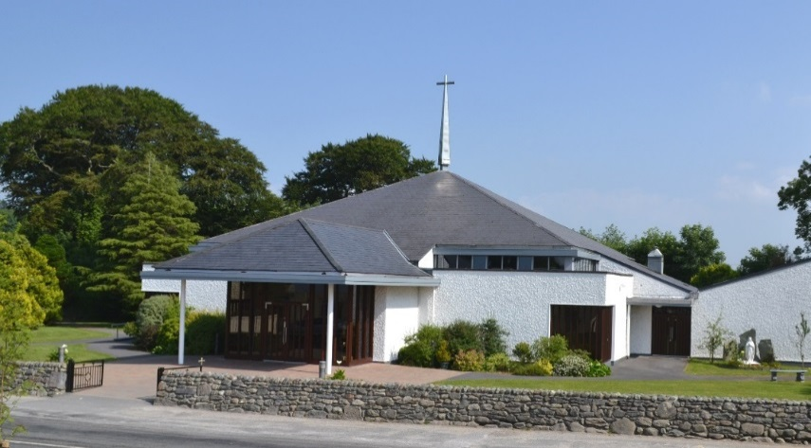
Kilcummin Parish Newsletter
Fr. Kieran O’Brien, Fr. Niall Geaney, Fr. Kevin McNamara, Fr. Padraig Kennelly, Fr. Niall Howard,
Fr. Jim Lenihan.
For a priest in an emergency at any time call
064 6631014 / mobile 087 6501998
www.kilcumminparish.com
Email: kilcummin@dioceseofkerry.ie
Priest on duty this Sunday contact
Fr. Niall Howard 087 6501998

Just a Thought

We gather each week to form the church: the community who follow Jesus as the way to the Father, and who encounter Jesus, and become one with him, when we gather about His table. It is this encounter with Jesus that makes this a sacred place and a sacred event. At our gathering today we are reminded in the gospel that one of the other sacred places where we can encounter the Son of God is in marriage: the union, indeed, of a married couple is the image of the bond that exists between Jesus Christ and us, His church.

27th Sunday in Ordinary Time. 03/10/2021
Priest on duty this weekend: Fr. Niall Howard 087 6501998
Masses for the coming week
Sat.2nd Oct. | 7.30pm | Fred O’Sullivan R.I.P. Lyreatough.
Sun. 3rd Oct. | 11.30am | Private family intention.
Tue. 5th Oct. | 9.30am  10.00am | People of the Parish  Adoration.
Thu. 7th Oct. | 7.30pm | Family intentions.
Sat. 9th Oct. | 7.30pm | Michael and Ann O’Riordan R.I.P. Coolick.
Sun. 10th Oct. | 11.30am | Kilcummin Historical Group – Deceased members of the Parish in the Irish War of Independence.

Eucharistic  Ministers | 9th & 10th October | 16th & 17th October
7.30pm Vigil | B. Lenihan.  G. Pigott.  M. O’Connor.  B. Fleming. | B. Lenihan.  G. Pigott.  M. O’Connor.  B. Fleming.
11.30a.m. | M. O’Sullivan. B.O’Sullivan. Mgt. O’Sullivan. | M. O’Sullivan. B. O’Sullivan.  Mgt. O’Sullivan.

Offertory Collection: €760.00. A sincere thank you to all who continue to hand in your weekly envelopes, Mass offerings & all other donations.
Parish Office. Open: Tues., Wed. & Fri 10.00am – 12noon. Webcam: www.churchservices.tv/kilcummin. Tel: 064 6643176/Mobile: 087 1339732, e-mail kilcummin@dioceseofkerry.ie
Commemoration Mass: The 11.30am Mass in Kilcummin on Sunday 10th October 2021 will commemorate those who died in the Irish War of Independence. This will be followed by the laying of a wreath at Kilcummin Mass Rock as organised by Kilcummin Historical Group.
Study Theology Online? Is this for you? The Priory Institute provides online Theology courses to degree level. Attend Saturday lectures in Tallaght or from the comfort of your own home. Register now for Autumn. Find out more on our website, www.prioryinstitute.com
Marriage Enrichment Weekend, 5th–7thNovember 2021. This is an online experience (using Zoom), starting on Friday evening at 8pm and ending on Sunday afternoon at 2.30pm. Details at https://www.marriageencounter.ie.
Junior Set Dancing classes continue every Friday night at the Recreational Hall commencing at 7pm. Further info. contact Mary Moriarty
on 087-9620135.
Vacancies will exist shortly on the Kilcummin Rural Development C.E. Scheme for the positions of Kitchen Assistant and Retail Assistant in Killarney Town, Information Provider in Killarney Town and for a Caretaker/Maintenance in Kilcummin. These positions are a development opportunity and no experience is necessary. Accredited training will be provided to support your career. Please contact your Local Intreo Office to check your eligibility. To apply, please forward your CV for the attention of the Supervisor to the Rural Development Office by post or email: john kilcumminparish.com Contact John 086-1579381.
Commemoration Mass: The 11.30am Mass in Kilcummin on Sunday 10th October 2021 will commemorate those who died in the Irish War of Independence. This will be followed by the laying of a wreath at Kilcummin Mass Rock as organised by Kilcummin Historical Group.
Local Honey for sale: Please contact Liam on 085 7279721 for details.
Kilcummin GAA: ‘Split The Pot’ Next draw this Sun. 3rd Oct. Tickets available from Kilcummin P.O., Paddy O’Keefe’s, Gattabawn or www.kilcummingaa.com.
GAA Lotto: There was no winner of the jackpot on Mon. 27th Sept. Next draw for a jackpot of €6,750 will take place Mon. 11th Oct. Please support, tickets available online and in local shops.
Fixture: Our seniors will play Ballydonoghue in Kilcummin at 2:30pm on this Sunday 3rd Oct. Again, this is a ‘ticket only gate’ and tickets can be purchased via the following link https://www.universe.com/users/kerry-gaa-VLF1SR We kindly ask our usual stewards to be at the club for 1pm please. Many thanks.
Music Lessons: Instruments: Piano/Keyboard, Accordion, Banjo, Tin-whistle, and Fiddle/violin. Classical and traditional music catered for. Fully qualified and Garda vetted teacher. Excellent rates. Tel. 087 9253224/087 9014681 after 3pm.
Senior Help Line is open every day of the year from 10am to 10pm. Our LoCall number is 1850 440 444 and no landline calls costs more than 30 cent irrespective of length. We are just a telephone line, but we seem to make a difference.
Killarney Al-anon meetings have now resumed on Tuesday nights at 8.30pm. Venue: St. Claire’s House, Beech Road. All most welcome.
Kilcummin Rural Dev. Office provides a full Secretarial Service to all groups and individuals. Assignments, Essays, Projects, C.V.’s and Wedding booklets professionally typed, confidentiality assured. Other services include photocopying, laminating, e-mail, paying your motor tax and your property tax online. Emails to the Dept of Agriculture for the
movement of cattle can also be sent from the office. Tel: 064-6643357 or
email: info@kilcumminparish.com

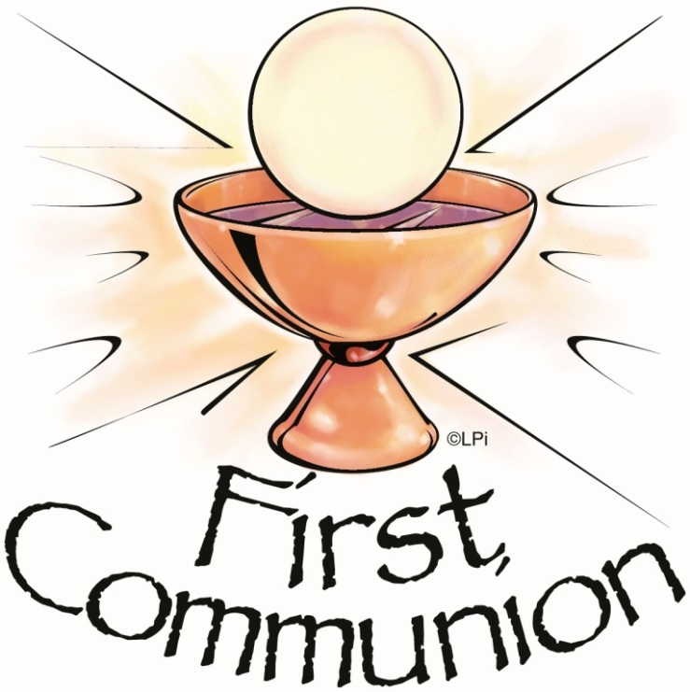

Holy Communion 2021

Our prayers and good wishes to the children from Anabla, Coolick and Kilcummin National Schools who celebrated their First Communion in our Parish last weekend;
Ella, Jamie, Anna, Teagan, Seán, Liam, Aodhán, Shane, Cillian, Brooke, Kyle, Evan, Sarah, Niall Ellie-Anna, Emma, Hugh, Isla, Lily, Niamh, Fionn, Paddy, Páraic, Cian, Ruby, Grace, Nessa, Aoibhinn, Éabha, Saoirse.

Note of Appreciation

We would like to acknowledge the generosity of so many people who were involved in the preparation and celebration of the occasion, in particular those involved in cleaning and decoration of the altar area, inside and outside the church, our musicians, sacristan, volunteers and everyone who participated in the ceremony. Our sincere thanks to the parents for their support, and we are particularly grateful to the staff of our three schools. We would also like to thank Fr. Jim and Fr. Kevin.

