**Renewing faith, hope and love: Pope Francis’ message for Lent 2021/**

**Athnuachan chreidimh, dhóchais agus ghrá: Teachtaireacht an Phápa Proinsias Carghas 2021**

In his message for Lent 2021, Pope Francis calls on the faithful to “renew our faith, draw from the living waters of hope, and receive with open hearts the love of God.” Grounding his reflection on the Paschal Mystery, the Pope says, “This Lenten journey… is even now illumined by the light of the resurrection, which inspires the thoughts, attitudes and decisions of the followers of Jesus.” He goes on to say that the journey of conversion, through fasting, prayer, and almsgiving, “makes it possible for us to live lives of sincere faith, living hope, and effective charity.” After reminding us that “every moment of our lives is a time for believing, hoping, and loving,” Pope Francis concludes by saying:

*"The call to experience Lent as a journey of conversion, prayer and sharing of our goods, helps us – as communities and as individuals – to revive the faith that comes from the living Christ, the hope inspired by the breath of the Holy Spirit and the love flowing from the merciful heart of the Father."*

<https://www.vaticannews.va/en/pope/news/2021-02/renewing-faith-hope-and-love-pope-francis-lenten-message.html>

**February 22 to 7 March 2021 Fairtrade Fortnight/ Coicís Chothromaíochta Thrádála**

For two weeks each year at the end of February and start of March, thousands of individuals, companies and groups across the UK come together to share the stories of the people who grow our food and drinks. mine our gold and who grow the cotton in our clothes, people who are often exploited and underpaid.

In 2021, Fairtrade Fortnight will feel very different. 2020 has been a hard year for everyone and we know that physically campaigning and meeting people will continue to be challenging in 2021 but we have also heard from so many of you that you want to continue to support Fairtrade through this time.  The COVID-19 pandemic has shown us more than ever how interconnected we are globally. This interconnection is at the very heart of the Fairtrade message and is where your role begins. You are part of the Fairtrade movement and you have the power to drive long-term change, not only with your shopping choices but with your support in spreading the message. We just have to do this a little differently in 2021!

**FAIRTRADE FORTNIGHT 2021 IN SCHOOLS**

Our ‘Climate, Fairtrade and You’ Education Packs have been produced for teachers and educators to discuss how the climate crisis affects farmers and workers overseas. Through assemblies (designed with social distancing in mind!), lesson plans and activities, young people will have the opportunity to discover how their choices can impact people around the world, but also the planet that we live on.

<https://schools.fairtrade.org.uk/take-action/fairtrade-fortnight-2021/>

**The Pope's Monthly Intentions for March 2021 / Intinní an Phápa, Márta 2021**

As you are aware, each year, the Holy Father asks for our prayers for a specific intention each month. You are invited to answer the Holy Father's request and to join with many people worldwide in praying for this intention each month.For March 2021, the Pope’s intention is for the ***Sacrament of reconciliation***  
“Let us pray that we may experience the sacrament of reconciliation with renewed depth, to taste the infinite mercy of God”.

Guímis go bhfaighmid taithí ar bhealach nua domhain ar shacraimint an athmhuintearais ionas go bhfaighimid blaiseadh de thrócaire gan teorainn Dé.

<http://popesprayerusa.net/popes-intentions/>

<https://www.usccb.org/prayer-and-worship/prayers-and-devotions/the-popes-monthly-intention>

**March 1st St. David of Wales/ Naomh Dáiví na Breataine Bige** 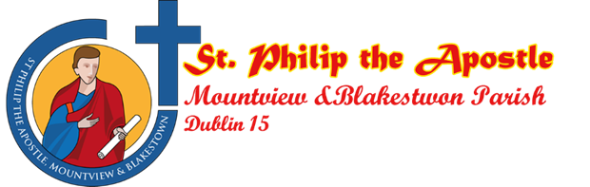

Today’s feast day reflection is shared with us by Jewel from Clonsilla, Dublin 15. Check out Jewel’s Youtube video! <https://youtu.be/NGxZIzRls2Y>

**Today, March 1st, we celebrate the feast of *Saint David of Wales.**

While little is factually known about his life, it is known that he became a priest, engaged in missionary work, and founded many monasteries, including his principal abbey in southwestern Wales.

Many stories and legends sprang up about David and his Welsh monks. Their austerity was extreme. They worked in silence without the help of animals to till the soil. Their food was limited to bread, vegetables and water.

Saint David travelled throughout England and Wales, rebuilding monasteries that had been abandoned or fallen into disrepair. He is credited with the re-founding of over ten such monasteries, including those prominent in Glastonbury and Bath.

In about the year 550, Saint David attended the Synod of Brevi (Llandewi Brefi in Cardiganshire), a gathering in which the church was challenged by the heresies of government and non-believers. As legend tells, Saint David addressed the crowd with extreme eloquence, during which many were converted to the faith.

He tirelessly defended the faith, built up the church, and withstood political pressures of the times to renounce of modify the teachings of God. He entered into even the most menial of tasks with joy, inspiring his brothers to do the same.

His last words to his monks and subjects were: “Be joyful, brothers and sisters. Keep your faith, and do the little things that you have seen and heard with me.” Over 50 churches in South Wales were dedicated to him in pre-Reformation days. He was canonized by Pope Callistus II in 1123.

*Saint David of Wales, pray for us.*

**March 1st** **World Day of Prayer / Lá Domhanda Urnaí**

**“Build on a Strong Foundation”**

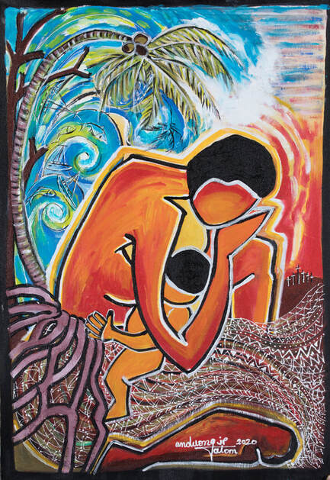

World Day of Prayer is a global ecumenical movement led by Christian women who welcome you to join in prayer and action for peace and justice. The WDP 2021 program is based on **Matthew 7:24-27** where Jesus tells a story about the kingdom of heaven using the image of a house and the land on which the house is built. “In Jesus’ story, the wisdom of the builder of the house comes from hearing and acting on the word of God, which is a word of love. This is the foundation on which our sisters call us to build our homes, our nations and the world. A call of faith to be earnestly considered when responding to the prayer of commitment: “What is the house that you would build?” In receiving their voice as a gift of wisdom, we share their hope and creatively engage our communities in "Informed Prayer. Prayerful Action." <https://worlddayofprayer.net/index.html>

**March 8th St. John of God / Naomh Eoin le Dia**

**Saint John of God’s Story**

Having given up active Christian belief while a soldier, John was 40 before the depth of his sinfulness began to dawn on him. He decided to give the rest of his life to God’s service, and headed at once for Africa where he hoped to free captive Christians and, possibly, be martyred.

He was soon advised that his desire for martyrdom was not spiritually well based, and returned to Spain and the relatively prosaic activity of a religious goods store. Yet he was still not settled. Moved initially by a sermon of Saint John of Avila, he one day engaged in a public beating of himself, begging mercy and wildly repenting for his past life.

Committed to a mental hospital for these actions, John was visited by Saint John, who advised him to be more actively involved in tending to the needs of others rather than in enduring personal hardships. John gained peace of heart, and shortly after left the hospital to begin work among the poor.

He established a house where he wisely tended to the needs of the sick poor, at first doing his own begging. But, excited by the saint’s great work and inspired by his devotion, many people began to back him up with money and provisions. Among them were the archbishop and marquis of Tarifa.

Behind John’s outward acts of total concern and love for Christ’s sick poor was a deep interior prayer life which was reflected in his spirit of humility. These qualities attracted helpers who, 20 years after John’s death, formed the Brothers Hospitallers, now a worldwide religious order.

John became ill after 10 years of service, but tried to disguise his ill health. He began to put the hospital’s administrative work into order and appointed a leader for his helpers. John died on the 8th March 1550 aged 55. He was canonised in1690. A few years after his death those who were his followers were recognised as a religious order and called the Hospitaller Brothers of St. John of God. Today the work which John began in a porch in Granada continues in 52 countries in the world and covers a wide range of care for those with physical and learning disabilities, the homeless and poor, those with mental health problems and the elderly.

<https://www.franciscanmedia.org/saint-of-the-day/saint-john-of-god>

**March 13th 8th Anniversary of Pope Francis to the Papacy / Cothrom 8 mbliain ó toghadh an Pápa Proinsias ina Phápa**

On March 13th 2021, his Holiness Pope Francis marks the 8th anniversary of his election by the papal conclave as Bishop of Rome and leader of the Catholic Church.

**Meet Pope Francis!**

Pope Francis was born Jorge Mario Bergoglio on December 17, 1936, in Buenos Aires, Argentina. He felt the call of God and was ordained a Jesuit priest on December 13, 1969. A Jesuit means that he belongs to the order known as the Society of Jesus, founded by St. Ignatius of Loyola. Jesuits are known for traveling the world to spread the word of God and being missionaries who serve the poor and fight injustice.

In Rome, Pope Francis, or Francisco, is known as il Papa, which means Father. The pope is the Bishop of Rome and the leader of the worldwide Catholic Church. He lives in Vatican City, which is a municipality inside the city of Rome. In his time as pope, Francis has shared a vision of Church that emphasizes hope, mercy, and care for each other. Pope Francis is the first Jesuit pope.

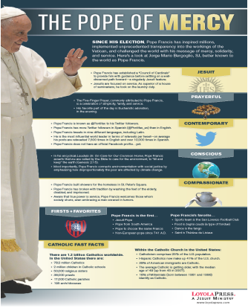

**Facts!/ Fíricí!**

**Name:** Jorge Mario Bergoglio

**Born:**December 17, 1936

**Where:**Buenos Aires, Argentina

**Family:**He is the eldest of five children, born to Italian emigrants who settled in Buenos Aires, Argentina.

Favorite Soccer Team is the San Lorenzo de Almagro football club

He once worked as a bar bouncer and a janitor before joining the Jesuits.

**Ordained:**December 13, 1969

**Order:**the Society of Jesus, the Jesuits.

**Became Pope:**March 13, 2013

The above poster-sized resource (11” x 17”)is available for classroom display, or send copies home with your students for families to learn more about Pope Francis, at:

<https://www.loyolapress.com/our-catholic-faith/scripture-and-tradition/church-leadership/pope-francis>

**March 14h Mother’s Day/Laetare Sunday**

**Lá na Máithreacha/ Domhnach an áthais**

The Fourth Sunday of Lent is also known as ‘Laetare Sunday.’ Laetare is the Latin word for ‘rejoice’ and so this Sunday is a day of joy in the middle of Lent. In some churches priests wear rose pink vestments instead of the purple ones that are worn on the other Sundays of Lent. Mother’s Day used to be called Mothering Sunday and we have celebrated this special day in Ireland for hundreds of years. As Christianity spread throughout Europe, Mother’s Day celebrations were held on the fourth Sunday of Lent – Laetare Sunday or ‘mid-Lent’ Sunday – the celebrations were adapted to honour the Virgin Mary and the ‘Mother Church’. Customs began to dictate that a person visit the church of his/her baptism on this day. People also attended the mother church of their parish, laden with offerings.

[**https://www.catholicculture.org/culture/liturgicalyear/calendar/day.cfm?date=2020-03-22**](https://www.catholicculture.org/culture/liturgicalyear/calendar/day.cfm?date=2020-03-22)

**March 17th St. Patrick / Naomh Pádraig**

Turning to Patrick—a crucial figure in Irish memory since the seventh century—memory’s headlines run like this: a young British boy from a well-off clerical family was carried off into slavery in Ireland; he later escaped, eventually became a bishop, and returned to Ireland as a missionary. He so effectively preached the Gospel that soon the whole island was Christian, and he did the job so well that within a century Ireland was a powerhouse of faith, with monasteries, scholars and missionaries of her own. And we know more about Patrick than any other fifth-century individual from these islands owing to his two surviving letters: one is now known as his ‘confession’, and the other is a letter excommunicating the soldiers of the slaver Coroticus. These writings are seen as a rugged witness to his simple holiness. Patrick is, therefore, the father of Irish Christianity, the ‘apostle of Ireland’, the ‘patron of the Irish’.

<https://www.historyireland.com/st-patrick/st-patrick-the-legend-and-the-bishop/>

For a short film on the biography of St. Patrick, which can be shown in one class period, see:

<https://youtu.be/A4h4PKYikRg>

**March 19th St. Joseph / Naomh Íosaf**

***A man of Honour and Creativity***

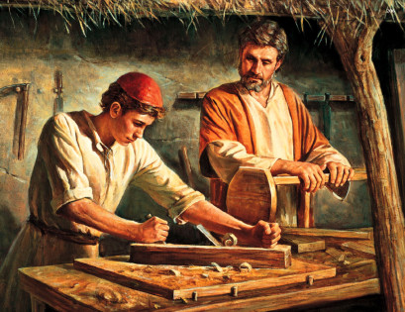Matthew also describes Joseph as “*a man of honour*“. When he learned of Mary’s pregnancy, he had already chosen the option of mercy and compassion when he decided not to divorce her publicly, but following some kind of encounter with God (“the angel of the Lord”) over the matter, he sensed God was asking him to take Mary into his home as wife, to treat the child as his own and to give him the divinely designated name, Jesus, thus indicating that “he would save his people from their sins” (Mt 1:18-21). Matthew’s readers will understand this to mean that Jesus fulfils the function of the atonement sacrifices of the temple.

Matthew (ch 2) infers Joseph’s protection of the child Jesus against Herod, the flight into Egypt and subsequent return to, and re-settling in Nazareth . Also in Mt 13:55, Jesus is referred to – somewhat with contempt – as “the carpenter’s son”, without naming his adoptive father, as if Jesus were someone who had risen above his station and as if carpentry were a somewhat dishonourable profession. *Joseph was a man of insightful creativity*

<https://www.catholicireland.net/saintoftheday/st-joseph-1st-century/>

**Pope Francis proclaims “Year of St Joseph”**

With the Apostolic Letter **“Patris corde”** (“With a Father’s Heart”), Pope Francis recalls the 150th anniversary of the declaration of Saint Joseph as Patron of the Universal Church. To mark the occasion, the Holy Father has proclaimed a “Year of Saint Joseph” from today, 8 December 2020, to 8 December 2021. In the Apostolic Letter Pope Francis describes Saint Joseph as a beloved father, a tender and loving father, an obedient father, an accepting father; a father who is creatively courageous, a working father, a father in the shadows.

<http://www.vatican.va/content/francesco/en/apost_letters/documents/papa-francesco-lettera-ap_20201208_patris-corde.html>

<https://www.vaticannews.va/en/pope/news/2020-12/pope-francis-proclaims-year-of-st-joseph.html>

**The official prayer of the Year of St. Joseph—To you, O blessed Joseph**

To you, O blessed Joseph, do we come in our afflictions, and having implored the help of your most holy Spouse, we confidently invoke your patronage also.

Through that charity which bound you to the Immaculate Virgin Mother of God and through the paternal love with which you embraced the Child Jesus, we humbly beg you graciously to regard the inheritance which Jesus Christ has purchased by his Blood, and with your power and strength to aid us in our necessities.

O most watchful guardian of the Holy Family, defend the chosen children of Jesus Christ; O most loving father, ward off from us every contagion of error and corrupting influence; O our most mighty protector, be kind to us and from heaven assist us in our struggle with the power of darkness.

As once you rescued the Child Jesus from deadly peril, so now protect God’s Holy Church from the snares of the enemy and from all adversity; shield, too, each one of us by your constant protection, so that, supported by your example and your aid, we may be able to live piously, to die in holiness, and to obtain eternal happiness in heaven. Amen.

**March 21st International Day of the Elimination of Racial Discrimination**

**Lá Idirnáisiúnta tiomnaithe do dhíothú Idirdhealú Ciníoch**

The International Day for the Elimination of Racial Discrimination is a day organised by the United Nations which aims to stop people being discriminated against because of their race.

The event is held on this day because on the 21st of March, 1960, police opened fire and killed 69 people at a peaceful demonstration in Sharpeville, South Africa against the apartheid “pass laws”. Pass laws were an internal passport system that was designed by the South African government to prevent the freedom of movement of Black people. This controlled where people could work, live and travel inside the country.

Whilst it is important to recognise the amazing work that has been done to start putting an end to Racism, we cannot ignore the facts. Many people throughout the world are still racially abused on a daily basis. In 2020 alone, there were a number of racist attacks on ethnic minority groups. It has become even more evident that days like International Day for the Elimination of Racial Discrimination are absolutely necessary as the fight against racial discrimination goes on.

**What Can We Do to Help Eliminate Racial Discrimination?**

* Recognise and teach that no matter what our skin colour, accent, the language we speak or where we are from, we are all equal and deserve the same rights and treatment.
* Make sure everyone feels included and welcome in any given situation.
* Encourage people to tell someone if they feel they are being discriminated against because of their race.
* If you think you see racism happening, tell a responsible adult and get help.

[**https://www.un.org/en/events/racialdiscriminationday/**](https://www.un.org/en/events/racialdiscriminationday/)

[**https://www.twinkl.ie/event/international-day-for-the-elimination-of-racial-discrimination-2021**](https://www.twinkl.ie/event/international-day-for-the-elimination-of-racial-discrimination-2021)

**March 22nd World Water Day / Lá Domhanda Uisce**

Water means different things to different people.

This conversation is about what water means to you.

How is water important to your home and family life, your livelihood, your cultural practices, your wellbeing, your local environment?

By recording - and celebrating - all the different ways water benefits our lives, we can value water properly and safeguard it effectively for everyone.

World Water Day Toolkit 2021 for use as a resource with students is available to download at :

<https://dublindiocese-my.sharepoint.com/:b:/g/personal/lily_barry_dublindiocese_ie/Eetnvmx1-_xDhcVWAi7PRWYBkZQUTGY5U-j4hLMF9mWoYA?e=tcIUHa>

<https://www.worldwaterday.org/>

**March 24th Oscar Romero**

***“Aspire not to have more, but to be more.”*– Saint Oscar Arnulfo Romero**

Born on August 15th 1917, Oscar Arnulfo Romero y Galdamez was sent to study for the priesthood in Rome and was ordained in April 1942. He embraced a simple lifestyle; he was a popular preacher who responded with real compassion to the plight of the poor. He gave dedicated pastoral service to the diocese of San Miguel for 25 years. He was ordained Archbishop of San Salvador in 1977. Over the years, the social and political conflict in El Salvador intensified, and from his Cathedral pulpit, Archbishop Romero became the voice of the voiceless poor. There, in a society of cover-up and lies, he spoke the truth of what was happening in the countryside; he denounced the killings, the torture and the disappearances of community leaders; he demanded justice and recompense for the atrocities committed by the army and police and he set up legal aid projects and pastoral programmes to support the victims of the violence.

On 24 March 1980, in El Salvador, Archbishop Oscar Romero was murdered while celebrating Mass. Recognizing him as “a martyr for the faith”, Pope Francis canonized him in 2018, he was beatified on 23 May 2015 in San Salvador.

<http://www.romerotrust.org.uk/who-was-archbishop-oscar-romero>

**Trócaire Romero Award**

The Romero Programme highlights the efforts of people in Ireland and across the world to raise awareness of human rights violations and support people who are experiencing hardship. Students can take part in Trócaire Awards Programmes, based on global justice issues. The Trócaire Romero Award is a student led awareness raising project that can be incorporated into a TY module, a CSPE project, or a RE topic. Prizes for most impressive entries and schools can find more details online

[**https://www.trocaire.org/getinvolved/trocaire-romero-award**](https://www.trocaire.org/getinvolved/trocaire-romero-award)

**March 25th Feast of the Annunciation / Teachtaireacht an Aingil**

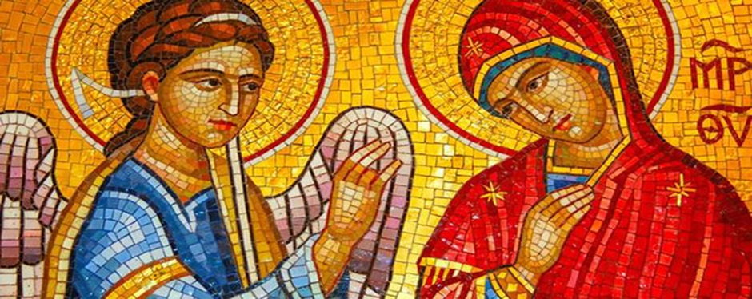

A tradition, which has come down from the apostolic ages, tells us that the great mystery of the Incarnation was achieved on the twenty-fifth day of March.

It was at the hour of midnight, when the most holy Virgin was alone and absorbed in prayer, that the Archangel Gabriel appeared before her, and asked her, in the name of the blessed Trinity, to consent to become the Mother of God. The feast of the Annunciation of the Lord celebrates Angel Gabriel's appearance to the Virgin Mary (Luke 1:26-38) and his announcement that she had been chosen to be the mother of the saviour of the world. Also being celebrated during this feast was Mary's fiat, which means **"let it be"** in Latin—her willing acceptance of the news.

Mary, in her selflessness, was open to the angel´s visit. She recognized who was speaking. She listened, received and responded. In so doing, she shows us the way to respond to the Lord's call in our own lives. God initiates a relationship and we respond in surrender to Him. This dynamic, this heavenly road, leads to a dialogue, a conversation, a way of life. By saying Yes, through our own Fiat, we are set apart. Consecrated. Made holy. Mary shows us that way.

The Annunciation, which means "the announcement," is observed almost universally throughout Christianity, especially within Orthodoxy, Anglicanism, Catholicism, and Lutheranism.

For further teaching resources see:

[**https://www.catholicculture.org/culture/liturgicalyear/calendar/day.cfm?date=2017-03-25**](https://www.catholicculture.org/culture/liturgicalyear/calendar/day.cfm?date=2017-03-25)

[**https://www.catholic.org/lent/story.php?id=40820**](https://www.catholic.org/lent/story.php?id=40820)

**As we continue our Lenten Journey through March:**

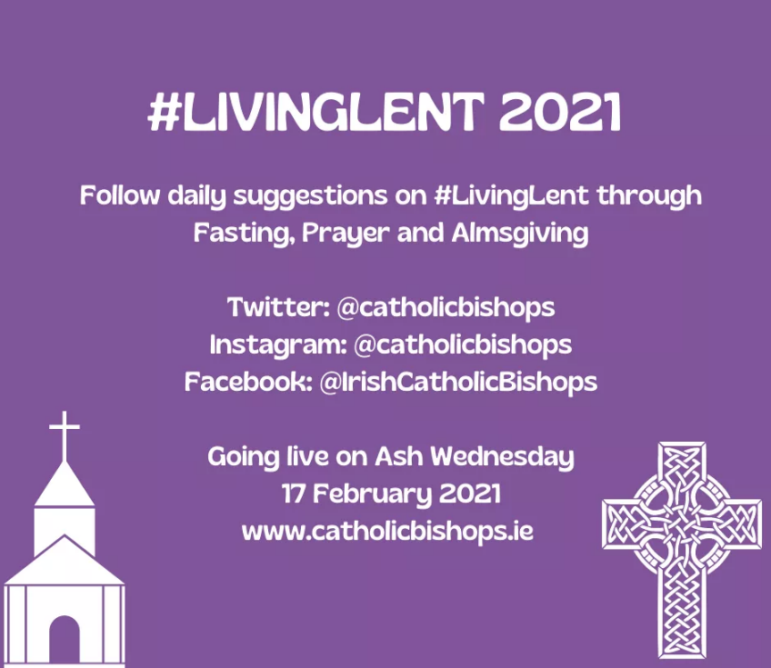

Remember to check out these great resources from the Irish Catholic Bishops for your students…

**#LIVINGLENT 2021**

Our #LivingLent digital media initiative invites the faithful to use social media to grow closer to God during this sacred season of Lent. There is a #prayer #fasting and #almsgiving prompt for everyday.

[www.catholicbishops.ie](http://www.catholicbishops.ie)

Check out these lovely short daily Lenten Reflections from Bishop Fintan Monahan. <https://youtu.be/SuyeQ4AZG0Q>

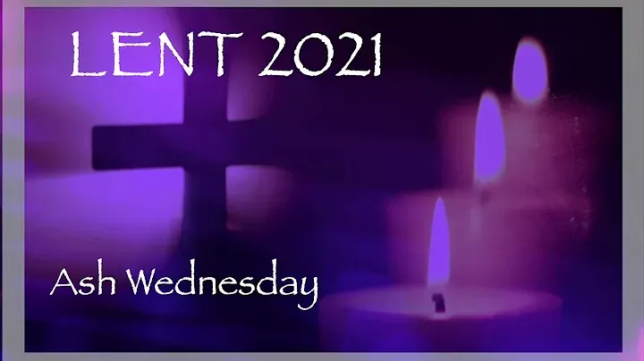

And beautiful inspirational words from Pope Francis; which you could ask your students to print as a poster, and display somewhere prominent at home to keep their Lenten Journey close to their hearts.

[**https://dublindiocese-my.sharepoint.com/:i:/g/personal/lily_barry_dublindiocese_ie/EaEQ-Av9tQlIpwPgHMCWxnIB32A7jrO7CRuApv7MSQ4OYw?e=aWWd7L**](https://dublindiocese-my.sharepoint.com/:i:/g/personal/lily_barry_dublindiocese_ie/EaEQ-Av9tQlIpwPgHMCWxnIB32A7jrO7CRuApv7MSQ4OYw?e=aWWd7L)

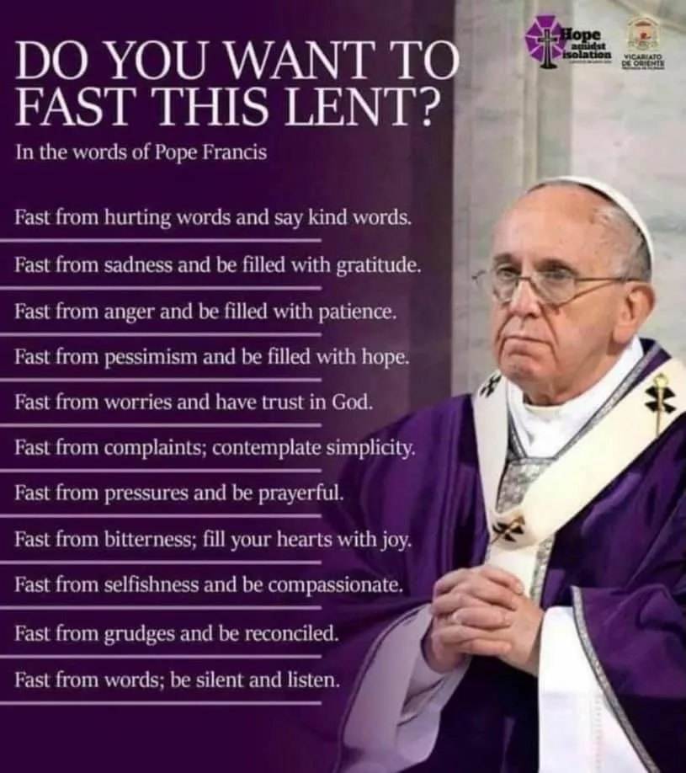

Just imagine that this Lent is going to be different from every other Lent we've experienced. This year’s Lent can be different. It will take an openness to God’s grace, a deep desire to receive what is being offered us, and a few signs and symbols to help us stay focused throughout the season. But if we do these things, God’s desire for our hearts and our desire for greater union with God will meet. Lent will no longer feel like a burden, but rather a blessing.

**March 24th Holika Dahan and Holi**

The great Indian festival of Holika Dahan in 2021, is on March 28 and Holi is on March 29.

Holi is considered as one of the most revered and celebrated festivals of India and it is celebrated in almost every part of the country. It is also sometimes called as the “festival of love” as on this day people get to unite together forgetting all resentments and all types of bad feeling towards each other. The great Indian festival lasts for a day and a night, which starts in the evening of Purnima or the Full Moon Day in the month of Falgun. It is celebrated with the name Holika Dahan or Choti Holi on first evening of the festival and the following day is called Holi. In different parts of the country it is known

with different names.  
The vibrancy of colors is something that brings in a lot of positivity in our lives and Holi being the festival of colours is actually a day worth rejoicing. Holi is a famous Hindu festival that is celebrated in every part of India with utmost joy and enthusiasm. The ritual starts by lighting up the bonfire one day before the day of Holi and this process symbolizes the triumph of good over the bad.

<https://www.holifestival.org/>

**Other Dates/Information (Dataí Eile/Eolas):**

**Resources as Gaeilge**

If you require any resources in Irish, please contact me and I will access them with the help of Sr. Mairéad Ni Bhuachalla.

**Nutrition for the Soul / Cothú don Anam**

Excellent resources available from Pat Murphy, including reflections, posters, and badges for your students. See <https://patsnutritionforthesoul.blogspot.com/>

**Other resources for Lent**

**Lent in Three Minutes**

<https://bustedhalo.com/video/watch-lent-3-minutes>

**MUSIC FOR LENT**

Bless the Lord, my soul (Taizé) <https://www.youtube.com/watch?v=t4Svh-9ohg4>

On Eagles’ Wings (Michael Joncas) <https://www.youtube.com/watch?v=MvpjxfWrjzY>

Your Faith in Me (Ian Callanan) <https://www.youtube.com/watch?v=nwoLUPHGsX4>

Psalm 91 "Be With Me, Lord" (Marty Haugen) <https://www.youtube.com/watch?v=mKzmYk6x4kE>

The Clouds’ Veil (Liam Lawton) <https://www.youtube.com/watch?v=yULkmEwEGYQ>

**Living Lent Daily**

“This Lent, foster a daily practice of spiritual calm where God is at the centre. Living Lent Daily is a daily e-mail series delivering fresh reflections based on the Scriptures of Lent. Each day’s message includes a quotation from the day’s Scripture readings and a brief reflection for meditation and prayer.The messages also include suggestions for further exploration of Lenten themes through additional online articles and prayers.”

[**http://www.loyolapress.com/our-catholic-faith/liturgical-year/lent/living-lent-daily**](http://www.loyolapress.com/our-catholic-faith/liturgical-year/lent/living-lent-daily)

**'Shine Online 2021‘ Two Great New Initiatives !**

This special event for young people (aged 11-18) is taking place on Friday 5 March (7.00-8.30pm).

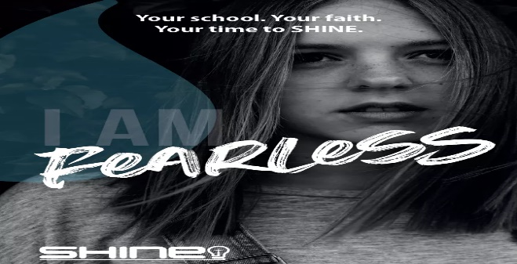SHINE aims to equip young people to live for God at school and create opportunities for them to explore the Christian faith for themselves. We aim to inspire teachers, Christian group leaders and pupils across the UK and Ireland to pray for their schools and to motivate them to reach out to others with the Good News of Jesus. SHINE is a 3 week video resource designed to equip young people to share their faith within school. Whilst many groups can’t meet at the moment, there are still ways that you can make use of the SHINE resources.

<https://www.shineinschools.com/what-is-shine/>

**NUA EASTER!!**

SU Ireland and SU Scotland have teamed up yet again to produce this free 3 part video series that provides a fresh perspective on Easter and why it matters for us today.  
**Available from March 9th.  
About:** 3 Episodes (plus a bonus video) - Aimed at 9-14 year old's  
Join Sarah Campbell, Darren Bourke and Mark Murray on a very unique and entertaining journey that highlights the meaning of the incredible events of Easter.  
Alongside the videos is a downloadable resource pack with quizzes and reflection activities formatted for youth groups, classroom delivery and home learning.  
<https://nuafilmseries.org/>



**Searmanas Athmhuintearais**

**Socrú Síos**

Suigh go compordach, do dhrom agus do cheann díreach agus do chosa ar an urlár.

Scaoil le haon teannas i do lámha, i d’aghaidh agus thart timpeall ar do bhéal agus do shúile. Scaoil le pé smaointe i do cheann a chuireann brú, nó strus, nó buairt ort.

Féach ar phictiúr éigin os do chomhair amach agus dírigh d’aire go hiomlán air. Mothóidh tú suaimhneas agus síocháin ionat féin.

Dún do shúile go séimh agus dírigh d’aire ar a bhfuil le cloisteáil timpeall ort.

Ansin scaoil le pé torann a chloiseann tú, ná bac leis, déan neamh-shuim de agus fágfaidh sin suaimhneach tú.

Éist leis an gceol, ceol suaimhneach, agus fuaimeanna ón nádúr le cloisteáil ó am go chéile.

Lig don cheol sin tú a thabhairt go háit álainn chiúin ina mbeidh sos agus saoirse, síocháin agus suaimhneas le fáil, áit a thaitníonn leat, áit ina mbíonn tú sona, sa bhaile i do sheomra féin, cois farraige, i ngairdín álainn, áit nach mbeidh aon duine ag cur isteach ort.

**Scéal**

Anois táim chun scéal a insint daoibh, scéal faoi dhuine a fuair bás. Nuair a casadh Dia air thug Dia cuireadh dó suí síos go compordach mar atá sibhse anois agus thaispeáin Dia fístéip dó, fístéip dá shaol iomlán. Bhí an-suim ar fad ag an duine san fhístéip ach bhí rud amháin ag cur mearbhaill air. Anseo is ansiúd bhí giotaí den téip **glan** agus chuir sé ceist ar Dhia cad ba chúis leis sin. D’fhreagair Dia gurbh eiseann – Dia - a ghlan amach na míreanna sin. Ansin do thuig an duine gur bhain na míreanna sin le heachtraí ina shaol ina ndearna sé rudaí go raibh náire agus aiféala air fúthu níos déanaí – an t-am a raibh sé mí-mhacánta le linn scrúdú sa scoil – an t-am a chuir sé an milleán ar dhaoine eile nuair a bhí sé féin ciontach – an t-am a bhailigh sé suim mhór airgid nuair a bhí sé mí-mhacánta agus é ag obair i mbun comhlachta ina dhuine fásta. Bhí aiféala air níos déanaí agus rinne sé aisíoc.

D’fhéach Dia air agus dúirt sé go cneasta leis: **“Tá na heachtraí sin go léir glanta amach ar fad agam agus dearmad déanta agam orthu.”**

**Scrúdú Coinsiasa**

Féach siar ar do shaol féin anois. An bhfuil aon eachtra, aon ócáid, aon rud a rinne tú go bhfuil aiféala ort anois go ndearna tú é?

**Gníomh Dóláis**

I do shamhlaíocht, téigh chuig na daoine go ndearna tú dochar dóibh. Abair leo go bhfuil brón ort, nach ndéanfaidh tú dochar dóibh arís, agus iarr maithiúnas orthu.

Ansin abair le Dia go bhfuil brón ort agus tabharfaidh Dia maithiúnas duit.

Abraimis le chéile:

**A Dhia, gabhaim buíochas leat as ucht do ghrá dom. Tá brón orm faoi mo pheacaí go léir: nach raibh grá agam duitse ná do dhaoine eile. Cabhraigh liom mo shaol a chaitheamh ar nós Íosa agus gan peaca a dhéanamh arís.**

**Faoistin**

Téigh chun faoistinechuig an sagart ansin. Tá an sagart in áit Íosa. Inis dó aon rud go bhfuilaiféala ort faoi. Tabharfaidh an sagart maithiúnas duit agus iarrfaidh sé ort paidir éigin a rá, nó dea-obair éigin a dhéanamh.

Tar-éis faoistine gabh do bhuíochas le Dia agus iarr ar Dhia cabhrú leat gan peaca a dhéanamh arís.

***Bí, a Íosa im’ Chroíse***

*Bí, a Íosa im’ chroíse is im’ chuimhne gach uair,*

*Bí, a Íosa im’ chroíse le haithrí go luath,*

*Bí, a Íosa im’ chroíse le dúthracht go buan,*

*Is a Íosa, a Dhia dhílis, ná scar choíche uaim.*

*Is é Íosa mo ríse, mo chara is mo ghrá,*

*Is é Íosa mo dhídean ar pheaca is ar bhás,*

*Is é Íosa mo aoibhneas, mo sheasamh de ghnáth,*

*Is a Íosa, a Dhia dhílis, ná scar liom go bráth.*

*Bí, a Íosa, go síoraí im’ chroí is im’ bhéal,*

*Bí, a Íosa, go síoraí im’ thuiscint is im’ mhéin,*

*Bí, a Íosa, go síoraí im’ mheabhair mar léann,*

*Is a Íosa, a Dhia dhílis, ná fág mé liom féin.*

***Traidisiúnta, Veritas Hymnal 31***