PARISH OF PRIOR NEWSLETTER
DUN GEAGAN – PORTMAGEE – THE GLEN
The Forth Sunday of Lent
Sunday 14th March 2021,
Email: prior@dioceseofkerry.ie Mobile: 087-0564348 (Fr Patsy)

Anniversary: Kitty McGill. May she rest in Peace.

All Masses online at www.ChurchServices.tv/Portmagee.
New Covid 19 Restrictions: All Public Worship will be Online.
Churches open for private prayer.
Mass Intentions for the coming week.
Sat 13th March | Portmagee | 7.30pm | PJ O Sullivan, Jim & Joan O Sullivan, Seami O Sullivan.  Kathleen Hickey.
Sun 14th March | The Glen | 10.00am | Private Intention.
Sun 14th March | Dun Geagain | 11.30am | Marie O Connor (Nee Devane)
Mon 15th March | Portmagee | 10.00am
Tues 16th March | The Glen. | 11.00am | St Finian’s Day.
Tues 16th March | Portmagee | 7.30pm | St Patrick’s Day Vigil Mass.  Nell & Patie Moran.  Mairead Falvey (Memorial Mass)
Wed 17th March | The Glen | 10.00am | Florence Moriarty.
Wed 17th March | Dun Geagan | 10.00am | Private Intention.
Thur 18th March | Portmagee | 10.30am | RTE Mass from Portmagee.
Fri 19th March | No Mass
Sat 20th March | Portmagee | 7.30pm | Kathleen Hickey, Kitty McGill, Mary Manning.  The O Connor Family Lative.
Sun 21st March | The Glen | 10.00am | Private Intention.
Sun21st March | Dun Geagain | 11.30am | Michael & Catherine Goggin & Deceased members of the Goggin & English Families.  Michael Sigerson & Deceased Family Members.

Readings.
The First Reading; There is nothing new in the messengers of God being ridiculed as this reading shows us. The reading also refers to defilement, infidelity, exile as well as God’s mercy.
The Second Reading: “We are created to live the good life as God’s artwork”. Do you believe this?
The Gospel: “God loved the world so much”. Our Church that did not always share this message of God’s love that enfolds every human being in our runaway world of fragility and fear.
Franciscan Friary: The Friary Office is operating a POSTAL SERVICE ONLY due to government restrictions on Monday to Saturday from 9.30am – 4.00pm daily. A selection of cards which include Sympathy, Easter, Mother's day, St Patrick’s day and Exam Mass bouquet cards can ordered by phone, 064 6631066 email killarney@franciscans.ie or post. No direct physical access permitted to the Friary Office. Adoration of the Blessed Sacrament daily from 7.30am – 7.00pm. Masses can be viewed live on Killarney Franciscans Facebook page daily at 10.00am.

Lent – a time to receive the love of God “In our Lenten journey towards Easter, let us remember the One who “humbled himself and became obedient unto death, even death on a cross” Pope Francis,
The facility to make Online donations to the Parish is now available.
www.dioceseofkerry.ie/parish/ballinskelligs.
On the welcome page of Ballinskelligs, you will see the blue donate link.

Follow the online instructions.
Your generosity is very much appreciated.
Scoil Bhréanainn Enrolment for Junior Infants School Year 2021 - 2022: Please contact the school for an information pack or if you have any queries. Telephone 0669477211 and email portmageens@gmail.com

Parishioners who wish to donate to Trocaire may put their donation in an envelope marked Trocaire. Thank you.
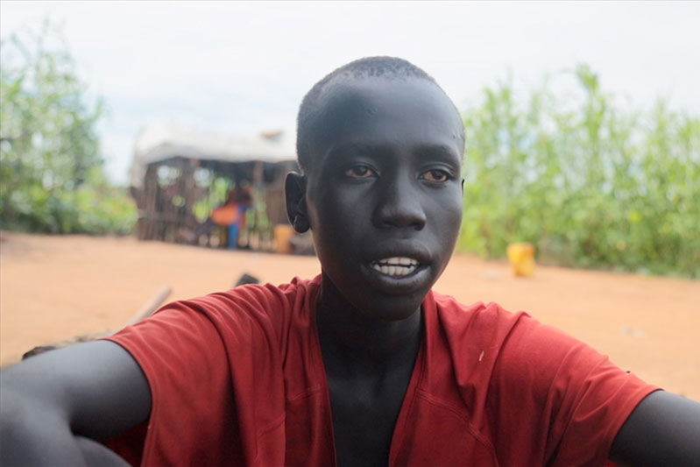
At 14 years of age, Malong has had to experience things no child should have to. When we spoke with him, he spoke enthusiastically about his hopes for the future. He wants to attend school, learn about the world, and have an opportunity to give himself and his family the chance of a brighter future. Despite the enormous challenges he faces, Malong is resilient and determined.
With a twinkle in his eye, he says, “Please pass on my regards to the people of Ireland. I greet you all.

