PARISH OF PRIOR NEWSLETTER
DUN GEAGAN – PORTMAGEE – THE GLEN
The Fifth Sunday of Lent
Sunday 21st March 2021,
Email: prior@dioceseofkerry.ie Mobile: 087-0564348 (Fr Patsy)

Recently Deceased; Maureen Lyne. Valentia & San Francisco.
Anniversary: William & Mary Butler. May they rest in Peace.

All Masses online at www.ChurchServices.tv/Portmagee.
Covid 19 Restrictions: All Public Worship will be Online. Churches open for private prayer.
Mass Intentions for the coming week.
Sat 20th March | Portmagee | 7.30pm | Kathleen Hickey, Kitty McGill, Mary Manning.  The O Connor Family Lative.
Sun 21st March | The Glen | 10.00am | Private Intention.
Sun21st March | Dun Geagain | 11.30am | Michael & Catherine Goggin & Deceased members of the Goggin & English Families.  Michael Sigerson & Deceased Family Members.
Mon 22nd March | Portmagee | 10.00am
Tues 23rd March | The Glen. | 10.00am
Wed 24th March | Dun Geagain | 10.00am
Thur 25th March | No Mass
Fri 26th March | Portmagee | 10.00am
Sat 27th March | Portmagee | 7.30pm | The Keane Family East End.  Katie & Mike Falvey
Sun 28th March | The Glen | 10.00am | Patsy & Mikey Goggin.
Sun 29th March | Dun Geagain | 11.30am | Liam Forde.

Readings.
The First Reading; “Learn to know the Lord” is a good aim for the last week of Lent. We have a God who “writes love on our hearts” and who “never calls our sins to mind”.
The Second Reading: Our wordless prayers of “Loud and silent tears” are counted by God.
The Gospel: We are given the seed of eternal life that is richly harvested in God’s “hour that has come” as all people are drawn to his presence.
The facility to make Online donations to the Parish is now available.
www.dioceseofkerry.ie/parish/ballinskelligs.
On the welcome page of Ballinskelligs, you will see the blue donate link.
Follow the online instructions.
Your generosity is very much appreciated.
Do you feel called to the Diocesan Priesthood? Or know anyone who may have expressed an interest. You are invited to participate in a virtual Discernment Eve. which will help and support those considering Diocesan Priesthood. During the presentation, the journey to the Priesthood and the life of a Priest will be explored and an opportunity for questions and discussion will be given.
For further info and to register, please email the National Vocations Office. info@vocations.ie or contact Fr. Joe Begley Diocesan Vocations Director on 027-63045.

Scoil Bhréanainn Enrolment for Junior Infants School Year 2021 - 2022: Please contact the school for an information pack or if you have any queries. Telephone 0669477211 and email portmageens@gmail.com

On Thursday night at 8pm TG4 will show a feature on The Glen on the programme “Bailte” showcasing beauty sports and some interviews.

Recovery Haven Kerry will facilitate a Lymphoedema awareness, information & management talk via
Zoom on Wednesday, March 24 th from 3-4pm. University Hospital Kerry physiotherapists Kiera O’Brien and Mary Hickey will host the online talk, explaining what Lymphoedema is and how to manage the condition. To register for this free event and receive your personal Zoom link, please call Recovery Haven Kerry at 066 7192122 or email reception@recoveryhavenkerry.com
Parishioners who wish to donate to Trocaire may put their donation in an envelope marked Trocaire. Thank you.
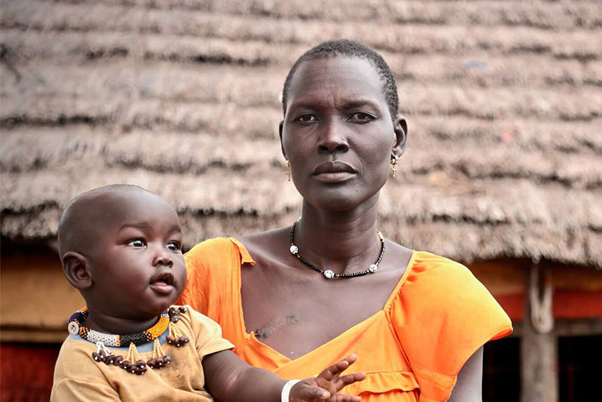
In conflict affected countries like South Sudan and The Democratic Republic of the Congo (DRC) the threat of gender-based violence sharply increases.
In South Sudan, 65% of women and girls have experienced violence.
South Sudan is one of the most difficult places in the world to live. After a decades-long war in which over two million people were killed, the country gained independence from Sudan in 2011. Independence gave hope that a new and peaceful chapter could start. Sadly, the country has remained wracked with violence and hunger.
In DRC over 1.9 million have experienced rape. DRC has been affected by decades of brutal armed conflict. Rape has been used widely as a tactic by armed groups and happens with alarming frequency. Trócaire works with communities to provide counselling and legal support to survivors of gender-based violence. We work with men and women to change attitudes and behaviours to prevent violence from happening in the first place. We also campaign for laws that protect women and respect their rights and dignity.

