Cultivating Hope
Lorna Gold, Global Catholic Climate Movement

I think we can all agree that we are living in the strangest of times. At times we all wonder what might happen next – between the growing climate and ecological crisis, the pandemic, the madness of political projects such as Brexit and the US elections. On top of that, there is a mounting financial crisis – if businesses can’t get back to normal soon, governments won’t be able to sustain them and so many jobs will be on the line. As we head towards winter, there is a growing sense of gathering storm clouds in our world.
In the midst of all of this my heart goes out to the young people of our world – especially the thousands who took to the streets last year to ask for climate justice. Just a year ago we saw the streets packed with young people and adults calling for urgent action to protect the future of the planet and our children and grandchildren. For Greta Thunberg, and all the Fridays for Future movement, this year has been particularly hard. Yes, the lockdown reduced climate emissions temporarily, but the climate and wider ecological crisis has been side lined….
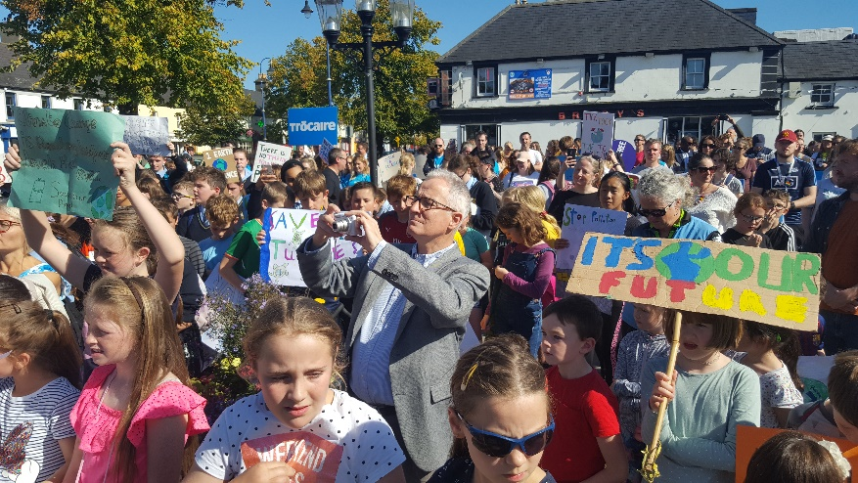
Picture 1 Maynooth Climate Strike, September 25th 2019
The movement has shown remarkable leadership in not gathering in crowds. But it has had to learn rapidly how to adapt and apply pressure in other ways rather than feet on the street. We have learnt what it means to truly respond in a crisis where survival is at threat – but we don’t seem yet to be applying those lessons more broadly.
In the face of this, there is plenty of reason to despair. This year we are witnessing an overwhelming sense of powerlessness as so many crises start to intertwine. Just think about the pictures of people facing forest fires or hurricanes in facemasks… trying to respond to one crisis whilst adapting to another. The problems just seem too big, the responses are too late. In many ways it can seem like we are edging ever closer to the climate cliff, as I drew in a little cartoon I drew about climate change a couple of years ago.
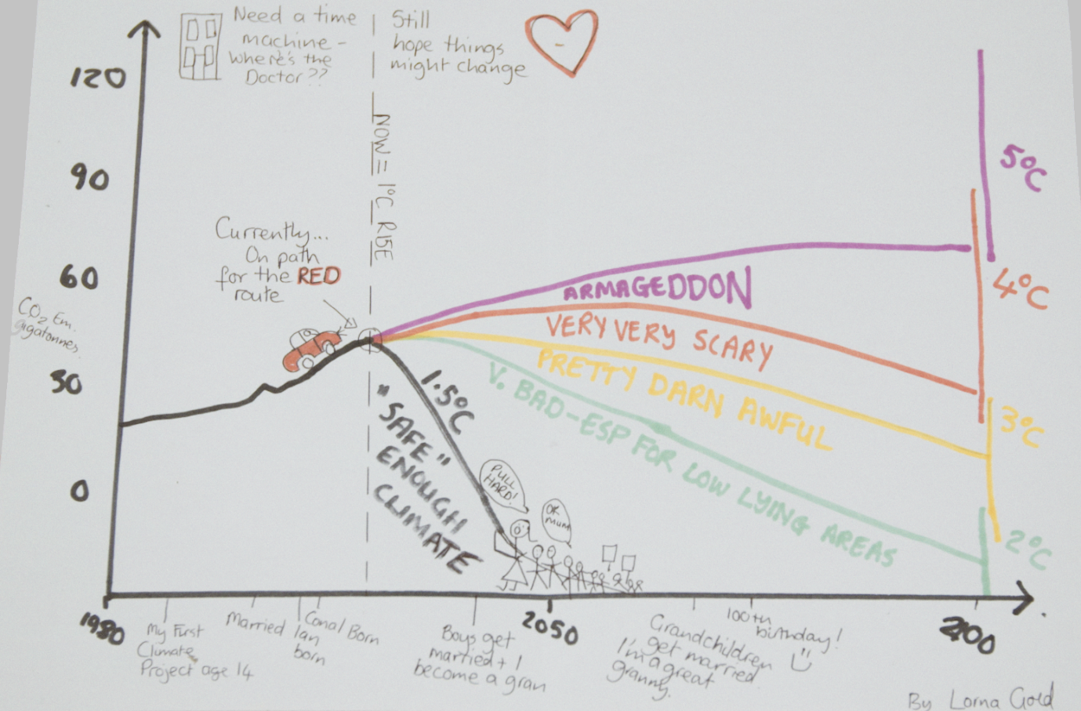
Picture 2 Putting ourselves in the climate crisis
In the midst of this madness, we want to focus on hope, on “cultivating hope”. Are we mad to hope at this time? The self-preservation reaction in this situation is to close down, switch off. I think many people are doing that right now. If we talk about hope today, I do not think that we can hold on to a glib hope – a kind of gloss of optimism which denies the basic facts of the situation. Our planet and our civilisation is on life support now – potentially terminally ill – that is the facts.
So where or how can we find hope? We urgently need to find hope in ourselves, in each other and in our world. I think the first step is really about acceptance of the reality of where we are. This is as much about a learning of the heart, as well as our heads. We know so much but we need to allow that to seep into us, to hold that sense of falling apart and let it wash over us.
Yet the Christian story, and many other mystical traditions, teach us a universal truth that has to be experienced to be understood fully. It is that darkness, held close and even embraced, can become a passage way, something that leads on to a deeper reality. In Christianity we call it the cross and resurrection Christian hope is born from the cross.
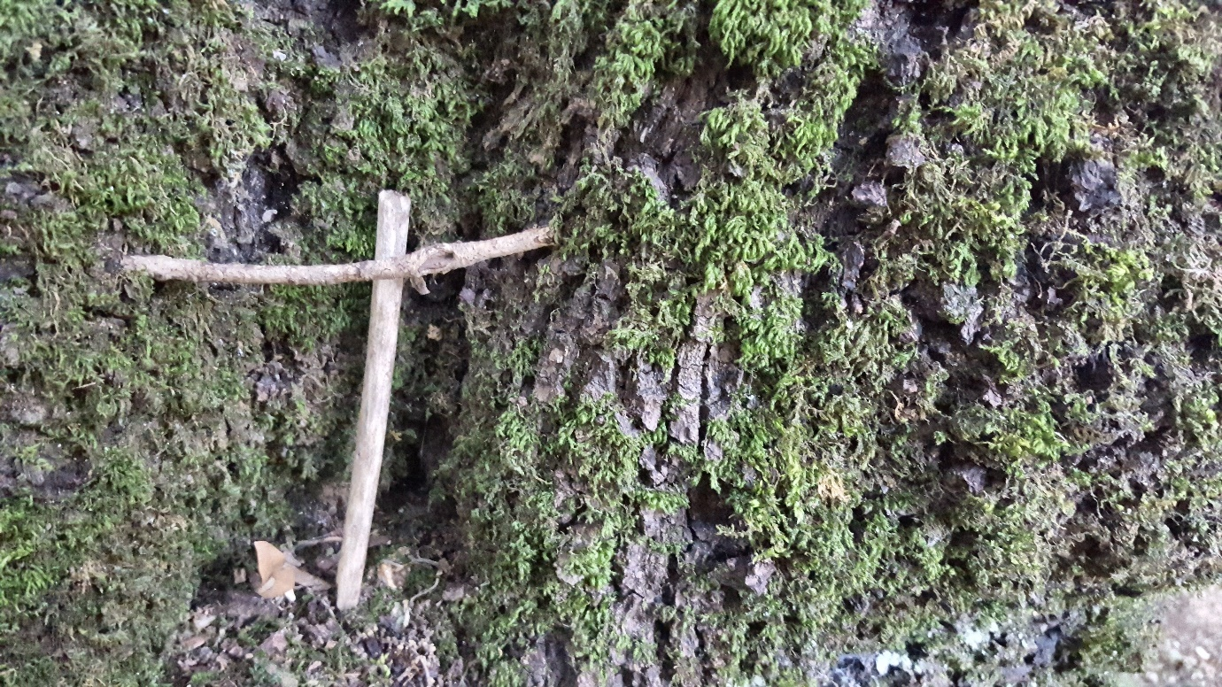 Picture 3 Wooden Cross in Assisi
Moving from that darkness into light, into hope, is a continuous journey. We can be thrust back into the darkness and doubt at times, sometimes unexpectedly and without warning. This year I would say many of us have experienced this, especially during lockdown. Yet in as much as we were thrust into despair, we also witnessed the miracle of compassion and loving action in equal measure.
This is why the idea of cultivating hope is so important. We almost need to choose which story, which future, we want to be part of: do we want to be part of this falling apart? Or do we want to see this time as the “Great Turning” as Joanna Macy calls it. It is almost like we need to create an ecosystem around us a means to help lift each other out of the dark – it is very difficult to do it on your own. We need to find others who can help us inhabit that future we so desperately want to believe in. As Pope Francis says in Laudato SI, our small actions take on a great significance. We need to create the conditions, the soil, the water, the sunshine that will help seeds of hope to germinate in our hearts, in our communities and in our world.
Nature can teach us so much when it comes to hope. During the lockdown, I decided to focus on my garden and start a little patch to grow my own food. That little patch of earth and those tiny seeds planted during lockdown - which have become giant sunflowers, tomatoes and dalias, attracting all sorts of birds, bees and butterflies, have spoken to me about hope. Every time I look out the window I feel like I am looking at a little miracle I helped to bring into being!
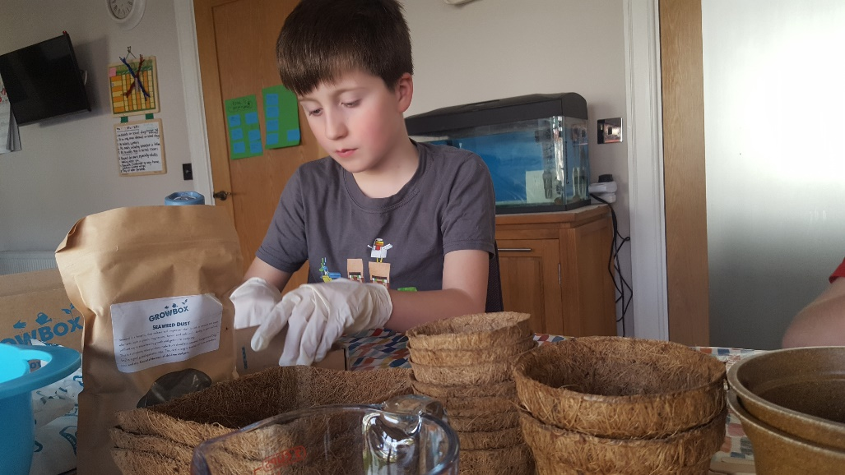
Picture 4 Learning to grow food during lockdown
Picture 5 Our lockdown garden blooming
This sense of maternal responsibility reminded me of the beautiful encounter I had in February when I met Pope Francis with the board of GCCM. After our meeting together he wanted to show us a tapestry of Creation. It was a beautiful picture of God as midwife – birthing the universe. He said to us that this is how we need to become – full of tenderness in our actions towards each other and all God’s creatures. This image stuck with me and made me wonder how we can help our world to be reborn, how we can sow hope in our own lives and in our communities.
As Leonard Cohen said: “there is a crack in everything, that’s how the light gets in.” It is precisely in that darkness that we can experience a greater fullness, grace, hope.

