SAFEGUARDING HANDBOOK
DIOCESE OF KERRY

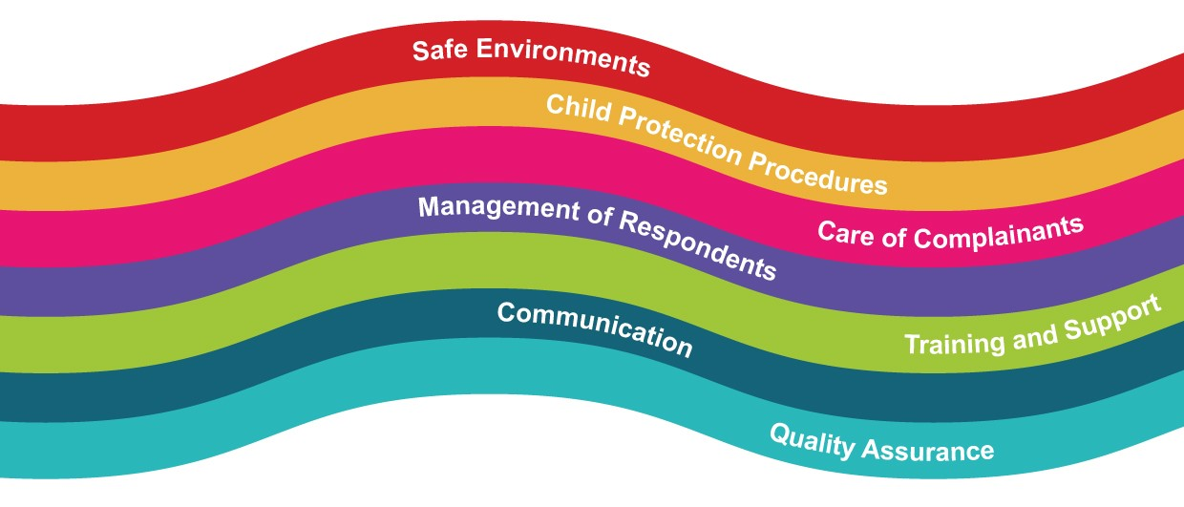

Content | Pages
Section 1 – Garda Vetting | 3 – 4
Section 2 – Parish groups working with children | 5 - 11
Code of behaviour for adults working with children | 5 – 6
Code of behaviour for children and young people | 6
Supervision ratios | 7
Dealing with accidents involving children | 8
Complaints procedure | 9
Whistle-blowing procedure | 10
Reporting abuse allegations, suspicions or concerns | 11
Section 3 – Safeguarding Checklists | 12 – 16
Altar Servers | 12
Choir groups | 13
Sacristans | 14
Eucharistic Ministers | 14
Parish Priest and Curates | 14
Priests from outside the Diocese, including retired Priests | 15
Priests who intend to engage in once off service | 15
Local Safeguarding Representatives | 16
Role of Safeguarding Representatives and Parish Priest | 16
Section 4 – Use of Church Property | 17
Ministry with children that is organised by the Church body as part of sacramental celebrations | 17
External groups | 17
Schools using Church property for sacramental celebrations | 17

Section 1 - Vetting procedures

How to know when vetting is necessary
A person requires vetting when a necessary and regular part of their work consists of the person having access to, or contact with, children and/or adults who may be vulnerable.
Vetting is not necessary when contact with children and/or adults who may be vulnerable is merely incidental to your work or activity.

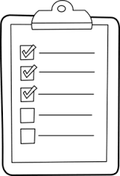
Who requires vetting?
- All Priests ministering in the Diocese
- Retired Priests who engage in occasional ministry in the Diocese
- Parish Safeguarding Representatives
- Persons supervising altar servers
- Sacristans
- Leaders of groups that involve children
- Eucharist Ministers visiting adults living alone or in nursing homes

How to apply for vetting

Part 1: Proof of identity
- Download, print and complete vetting invitation form (available on Diocesan website)
  - Vetting Invitation Form
  - Parent/Guardian Consent Form (for use by under 18’s who are applying for eVetting)

- Bring completed form along with appropriate identification to your local Parish Priest. Appropriate identification is highlighted on page two of the vetting invitation form
- Parish Priest will photocopy identification and vetting invitation form and store both securely
- Parish Priest will sign and post original invitation form to Diocesan Office

Part 2: Complete email application
- You will receive an email from the Vetting Office, please check your junk mail, occasionally the email will appear here
- Follow instructions in the email, you will be asked to enter the following: Place of birth; passport number; mother’s maiden name; and previous addresses.

Part 3: Vetting approval
- Once vetting is complete both the applicant and the Parish Priest will receive an email notification of the vetting outcome.

Section 2 - Parish Groups working with children
Codes of behaviour are essential for effective safeguarding practice. It is important to carefully read these guidelines and following them at all times. Codes of behaviour should be reviewed on an annual basis. Below are guidelines, each group should develop their own codes of behaviour based on these.

Code of behaviour for adults
It is important for all personnel to:
- Treat all children with respect and dignity
- Treat all children equally
- Model positive, appropriate behaviour to all children we come into contact with
- Be aware of the Church’s child protection and child safeguarding policy
- Challenge and report abusive and potentially abusive behaviour
- Develop a culture of openness, honesty and safety
- Develop a culture where children have permission to tell and to talk about any concerns or worries that they may have
- Respect each child’s boundaries and support them to develop their own understanding and sense of their rights
- Be aware of their responsibility for the safety of all children in their care
- Work in open environments
- Help children to know what they can do if they have a problem

Adults must never:
- Hit or otherwise physically assault or abuse children
- Develop sexual relationships with children
- Develop relationships with children that could in any way be deemed exploitative or abusive
- Act in any way that may be abusive or may place a child at risk of abuse
- Use language, make suggestions or offer advice that is inappropriate, offensive or abusive
- Do things for a child of a personal nature that they can do themselves
- Condone or participate in behaviour that is illegal, unsafe or abusive
- Act in any way that is intended to intimidate, shame, humiliate, belittle or degrade
- Engage in discriminatory behaviour or language in relation to race, culture, age, gender, disability, religion, sexual orientation or political views
- Consume alcohol, tobacco or illegal drugs while having responsibility for or in the presence of children

In general, it is inappropriate to:
- Take children away or to your own home, especially where they will be alone with you
- Involve children in one-to-one contact; activities should usually be supervised by at least two adults
- However, there may be two circumstances where this may occur:
  - In a reactive situation, for example when a young person requests a one-to-one meeting with you without warning, or where a young person has had to be removed from a group as part of a code of behaviour
  - As part of a planned structured piece of work (for example one-to-one music tuition).

Code of behaviour for children and young people
Children should be involved in drawing up a code of behaviour for themselves; however, it is important that in working with children, an appropriate adult with relevant skills and competencies participates to support them in developing the code of behaviour.
The methods used in creating a code of behaviour should be age and ability appropriate, with children being encouraged to avoid merely drawing up a list of prohibitions. Instead, the code should be comprised of positive statements about respect, and should consider what consequences ensue if the code is broken.
In developing the code, consideration should be given to the following:
- Treating everyone with respect
- Treating property with respect
- Not consuming alcohol, tobacco or illegal drugs
- Agreeing not to bring any physical item into the Church activity that may cause offence or harm to others
- Acting as a good role model
- Attending activities on time
- Signing in and out
- Turning off your mobile phone
- Telling someone you trust if you feel uncomfortable with any situation or individual
- Not using bad language
- Never bullying anyone or sending threatening messages

Supervision ratios
It is recommended that a certain number of adults be available to supervise a certain number of children; however, this is also dependent on whether the children have specific needs or requirements, and on the duration of the activity. At a minimum, two adults are always required for each activity.
Within each group the ratio of adults to children is determined by the age of the children involved:
- 0-1 year: one member of staff to three children
- 1-2 years: one member of staff to five children
- 2-3 years: one member of staff to six children
- 3-6 years: one member of staff to eight children
- 7-12 years: one member of staff to eight children
- 13-18 years: one member of staff to ten children

In addition, for overnight activities additional staff should be considered. If the group is mixed, a gender balance should be maintained.

Dealing with accidents involving children
If a child has an accident and injures himself/herself while attending a Church-run event, these procedures should be followed:
- Assess the injury and reassure the child. If the injury is severe or the child has lost consciousness, please contact the emergency services
- If the emergency services are called, contact with the child’s parents/guardians must be made urgently. Contact information should be found on the child’s membership/consent form
- If the parents/guardians are not available, it may be necessary for a leader to travel with the child to the hospital. If medical treatment is required, Church personnel may be asked about known allergies or existing medical conditions. Again, this information should be found on the child’s membership/consent form
- If the injury is minor, local application of treatment should be available from the first-aid box. There should be a fully stocked first-aid box to hand at all Church-related events. Remember to make a note of what has been used from the first-aid box so that it can be replaced at the earliest opportunity. Under no circumstances should any medication be given to a child, unless under parental or medical supervision
- As soon as possible after the accident, write up a report using an accident/incident report form (form 9, available on the Diocesan website). Once completed, this form should be stored in a safe place, in line with data protection, and treated as a confidential document
- Always inform parents/guardians of any accident that has occurred involving their child, regardless of how minor you consider it to be. It is good practice to give a copy of the accident/incident report form to parents/guardians
- It is good practice to keep blank copies of the accident/incident form with the first-aid box so that one can be easily filled out in the event of an emergency

Complaints procedure
A complaint is defined as a grievance and/or the raising of a concern about breaches of codes of behaviour. Allegations or suspicions of child abuse do not fall into this category of general complaints.
All complaints will be taken seriously and dealt with fairly and confidentially. Efforts will be made to quickly and informally resolve complaints through discussion with the parents/guardians, children/young people, volunteers/members of staff and clergy, as appropriate.
If a parent/guardian, young person or child is not satisfied with any aspect of the running of a particular activity, or the behaviour of any individual involved in that activity, the following steps should be taken: All complaints of this nature should be resolved using an open dialogue with the person responsible for the group or the Parish Priest. If resolution is not possible, the following step should be taken.
Steps to take:
- Complete complaint form and submit to the Parish Priest
- A letter acknowledging receipt of the complaint will be sent, enclosing a copy of the complaints procedure. All complaints must be thoroughly investigated
- The Parish Priest may organise a meeting to discuss and hopefully resolve the complaint
- Following the meeting or discussion, the Parish Priest will write to the complainant to confirm what took place and to set out any solutions that were agreed upon
- If a meeting is not agreeable or possible, the Parish Priest will issue a detailed written reply to the complainant, setting out their suggestions for resolving the matter
- If the complainant is still not satisfied at this point, they should contact the Parish Priest again. At the conclusion of this step, the Bishop may decide to take further action on the complaint

Whistle-blowing procedure

All staff and volunteers must acknowledge their individual responsibility to bring matters of concern to the attention of their supervisor/superior/manager.

Reasons for whistle-blowing:
- Each individual has a responsibility to raise concerns about unacceptable practice or behaviour
- To prevent the problem worsening or widening
- To protect or reduce risks to others
- To prevent yourself from becoming implicated

It is important to undertake the following steps:
- Voice any concerns, suspicions or uneasiness as soon as possible. The earlier a concern is expressed the sooner and easier action can be taken
- Try to pinpoint exactly what practice is of concern and why
- Approach your immediate superior/supervisor/manager
- If your concern is about your immediate superior/supervisor/manager, please contact your Parish Priest or the Diocesan Office
- Make sure a satisfactory response is secured – don’t let matters rest
- Ideally, concerns should be placed in writing, outlining the background and history, giving names, dates, locations and any other relevant information
- You are not expected to prove the truth of your complaint, but you need to demonstrate sufficient grounds for concern

Reporting abuse allegation, suspicion or concern
- Diocese of Kerry provides guidance and training on recognition of abuse, and clear procedures on what to do when a child protection concern arises, so that everyone knows how to respond appropriately
- This involves knowing who to tell and how to record it. It is important that the local reporting procedures are fully consistent with statutory legislation, regulations and guidance
- Reporting a concern can be a challenging responsibility. The procedure needs to ensure that everyone is clear what steps to take to ensure that the safety of children is the paramount consideration
- The reporting flow chart below refers to any child protection concern, including where the concern is about a situation or person involved in the Church. It is the responsibility of everyone in the Church to ensure that children who may need help and protection are not left at risk of abuse
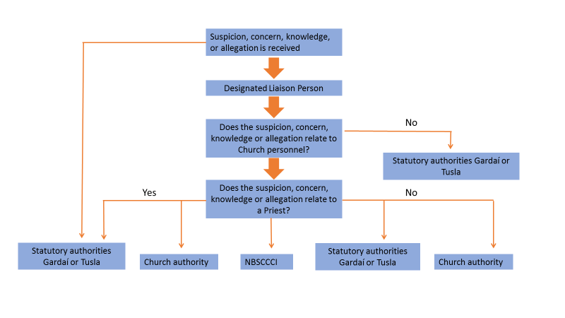
Figure 1: Guidance on reporting allegations of abuse

Section 3 – Safeguarding Checklists

Altar Servers
When is it necessary for altar servers to be supervised?
If altar servers are required to get ready in a private setting, for example, the sacristy then supervision is required.
If altar servers get ready in public view of the congregation supervision is not required.

Options for the supervision of altar servers
As with other supervision ratios two adults should be present, both of whom must be vetted.
- Parents of altar servers who have been vetted by the Diocese
- Any adult who has been vetted by the Diocese
- Members of other church groups who have been vetted
- Parish Safeguarding Representatives

- Checklist for persons supervising altar servers

- Vetting approval (requirement to renew vetting every 5 years)
- Form 4 – Adult Declaration Form
- Form 5 – Policy Agreement Form
- Form 6 – Code of Behaviour for Adults Working with Children and Young People
- Induction for new personnel in this position

- Checklist for parents of altar serving children

- Form 7 – Media Permission Form
- Form 8 – Child and Guardian Joint Consent Form
- Young people aware of appropriate code of behaviour
- Attend annual information session for parents and children

Choir Groups that involve members under the age of 18

Who requires vetting for choir groups?
The leader of the choir group requires vetting.

- Checklist for Choir Leaders

- Vetting approval (requirement to renew vetting every 5 years)
- Form 4 – Adult Declaration Form
- Form 5 – Policy Agreement Form
- Form 6 – Code of Behaviour for Adults Working with Children and Young People
- Induction for new personnel in this position
- Attend full-day Safeguarding Training (renew training every 3 years)
- Provide annual information session for parents and children

- Checklist for parents / guardians whose children are in the Choir

- Form 7 – Media Permission Form
- Form 8 – Child and Guardian Joint Consent Form
- Young people aware of appropriate code of behaviour
- Attend annual information session for parents and children

Sacristans
- Checklist for Sacristans

- Vetting approval (requirement to renew vetting every 5 years)
- Form 4 – Adult Declaration Form
- Form 5 – Policy Agreement Form
- Form 6 – Code of Behaviour for Adults Working with Children and Young People
- Induction for new personnel in this position
- Attend full-day Safeguarding Training (renew training every 3 years)

Eucharistic Ministers
- Checklist for Eucharistic Ministers visiting adults living alone or in nursing homes

- Vetting approval (requirement to renew vetting every 5 years)
- Form 4 – Adult Declaration Form
- Form 5 – Policy Agreement Form
- Form 6 – Code of Behaviour for Adults Working with Children and Young People
- Induction for new personnel in this position
- Attend Safeguarding Training

Priests
The Parish Priest has the overall responsibility for safeguarding children and vulnerable adults. In this capacity, the Parish Priest is supported by the Safeguarding Representatives and the Diocesan Safeguarding Co-ordinator.
- Checklist for Parish Priests & Curates

- Vetting approval (requirement to renew vetting every 5 years)
- Form 4 – Adult Declaration Form
- Form 5 – Policy Agreement Form
- Form 6 – Code of Behaviour for Adults Working with Children and Young People
- Attend full-day Safeguarding Training (renew training every 3 years)

Visiting Priests
Priests from outside the Diocese, including retired Priests
- Checklist for Priests from outside the diocese who intend to minister for short or long periods of time

- Seek permission of the Bishop: Details about the duration of the visit, the type of ministry and the location of ministry being considered
- Confirmation of good standing must be completed and submitted to Bishop
- Complete Garda vetting process
- Form 4 – Adult Declaration Form
- Form 5 – Policy Agreement Form
- Form 6 – Code of Behaviour for Adults Working with Children and Young People
- Apply for Celebret Card
- Attend full-day Safeguarding Training (renew training every 3 years)

Priest from outside the Diocese engaging in once off service
- Checklist for Priest who intend to engage in a once off service

- This applies for occasions like weddings, baptisms and funerals
- A Celebret Card must be produced to the Parish Priest

Local Safeguarding Representatives
Safeguarding Representatives support the Parish Priest in maintaining safeguarding standards in the Parish area. It is recommended that each Parish have two safeguarding Representatives.
- Checklist for safeguarding representatives

- Vetting approval (requirement to renew vetting every 5 years)
- Form 4 – Adult Declaration Form
- Form 5 – Policy Agreement Form
- Form 6 – Code of Behaviour for Adults Working with Children and Young People
- Induction for new personnel in this position
- Attend full-day Safeguarding Training (renew training every 3 years)

Role of the Safeguarding Representatives and Parish Priest
All groups and personnel that work with children:
All personnel have completed either the full-day Safeguarding Training Programme; Safeguarding Information Session, depending on their role
Induction with personnel who work with children is complete
All relevant safeguarding forms have been understood and completed
All groups working with children are aware of the safeguarding needs within the group setting
Ensure Garda Vetting is complete and up-to-date
Ensure that all parish groups involving children utilise the sign-in / sign-out registers
Support the completion of form 13 - Record of those in contact with young people
Safeguarding Representatives and Parish Priest complete the annual safeguarding audit

USE OF CHURCH PROPERTY THAT INVOLVES CHIDREN

- Ministry with children that is organised by a parish group as part of sacramental celebrations

Responsibility for safeguarding rests with the Parish Priest.

- External groups

Individual adults (parents/guardians/family members) approaching the parish priest to use Church property for a private function do not meet the requirement for vetting.
It is the sole responsibility of the parents/guardians to organise and supervise all children attending.
Parish Priest must ensure:
- Property is fit for use in terms of health and safety
- Groups using the property are aware of how to report any accidents resulting from the condition of the property
- Group completes Form 12 (available on Diocesan website) for use of Church Property, particularly ensuring that the group has its own insurance and safeguarding policy

- Schools using Church property for sacramental celebrations

The school and the parish priest need to agree who is responsible for safeguarding in each circumstance.

