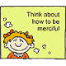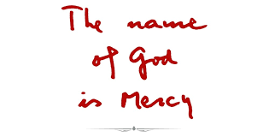

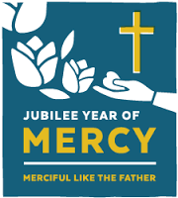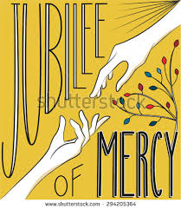

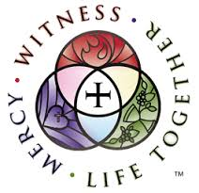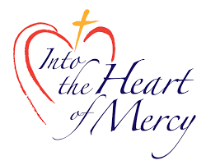
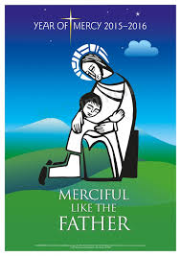

Mercy & Compassion Quotations

Have mercy on me, God, in your kindness
In your compassion, blot out my offence. Psalm 51:1

Blessed are the merciful, for they will receive mercy. Matthew 5:7
The compassionate heart is in communion with all of life and is willing to enter into suffering with the heart of Christ. Compassion includes awareness, attitude and action. A deeper and clearer look at compassion, the central quality of Christ, enables us to accompany the hurting ones of our personal lives and the larger world with loving kindness. Compassion also teaches us how to live as a person of unbounded love.
Joyce Rupp

Let your hearts be broken, not your garments torn, turn to the Lord your God again, for he is all tenderness and compassion, slow to anger, rich in graciousness, and ready to relent. Joel 2:13

The poor do not need our sympathy and our pity. The poor need our love and compassion. Mother Teresa
Compassion means to suffer with, to live with those who suffer. When Jesus saw the woman of Nain he realized, this is a widow who has lost her son, and he was moved by compassion. He felt the pain of that woman in his guts. He felt her pain so deeply in his spirit that out of compassion he called the son to life so he could give that son back to his mother. Henri J. M. Nouwen

Compassion is sometimes the fatal capacity for feeling what it is like to live inside somebody else’s skin. It is the knowledge that there can never really be any peace and joy for me until there is peace and joy finally for you too. Frederick Buechner

When you are compassionate with yourself, you trust in your soul, which you let guide your life. Your soul knows the geography of your destiny better than you do.
John O’Donohue

I have always found that mercy bears richer fruit than strict justice.
Abraham Lincoln

A new heart I will give you and a new spirit I will put within you: and I will remove from your body the heart of stone and give you a heart of flesh, Ezekiel 36:26

Reflection
May the door of my inner home be wide enough
to receive those who hunger for kindness,
those who are lonely, or isolated from friendship.
May it welcome those who have cares to unburden,
and pain to express.
May the door of my heart be narrow enough
to shut out pettiness and pride, envy and enmity.
May the door of my heart be closed to harshness
and indifference.
May the threshold of my heart be for all who enter
the doorway to understanding, acceptance and compassion.
Adapted from Joyce Rupp

Let your God love you
Be silent.
Be still.
Alone. Empty
Before your God
Say nothing.
Ask nothing.
Be silent.
Be still.
Let your God
Look upon you.
That is all.
He knows.
He understands.
He loves you with
An enormous love.
He only wants to
Look upon you
With His Love.
Quiet.
Still.
Be.

Let your God –
Love you. Edwina Gateley

From Pope Francis’ letter, The Face of Mercy 1
As we can see in Sacred Scripture, mercy is a key word that indicates God’s action towards us. He does not limit himself merely to affirming his love, but makes it visible and tangible. Love, after all, can never be just an abstraction. By its very nature, it indicates something concrete: intentions, attitudes, and behaviours that are shown in daily living.
The mercy of God is his loving concern for each one of us. He feels responsible; that is, he desires our wellbeing and he wants to see us happy, full of joy, and peaceful. This is the path which the merciful love of Christians must also travel. As the Father loves, so do his children. Just as he is merciful, so we are called to be merciful to each other.

From the Pope Francis’ letter, The Face of Mercy 9
In the parables devoted to mercy, Jesus reveals the nature of God as that of a Father who never gives up until he has forgiven the wrong and overcome rejection with compassion and mercy. We know these parables well, three in particular: the lost sheep, the lost coin, and the father with two sons (cf. Lk 15:1-32). In these parables, God is always presented as full of joy, especially when he pardons. In them we find the core of the Gospel and of our faith, because mercy is presented as a force that overcomes everything, filling the heart with love and bringing consolation through pardon.

From Pope Francis’ Letter, The Face of Mercy 8
Jesus, seeing the crowds of people who followed him, realized that they were tired and exhausted, lost and without a guide, and he felt deep compassion for them (cf. Mt 9:36). On the basis of this compassionate love, he healed the sick who were presented to him (cf. Mt 14:14), and with just a few loaves of bread and fish, he satisfied the enormous crowd (cf. Mt 15:37). What moved Jesus in all of these situations was nothing other than mercy, with which he read the hearts of those he encountered and responded to their deepest need. … The calling of Matthew is also presented within the context of mercy. Passing by the tax collector’s booth, Jesus looked intently at Matthew. It was a look full of mercy that forgave the sins of that man, a sinner and a tax collector, whom Jesus chose – against the hesitation of the disciples – to become one of the Twelve.

From Pope Francis’ letter, The Face of Mercy 8
With our eyes fixed on Jesus and his merciful gaze, we experience the love of the Most Holy Trinity. The mission Jesus received from the Father was that of revealing the mystery of divine love in its fullness. “God is love” (1 Jn 4:8,16)...

This love has now been made visible and tangible in Jesus’ entire life. His person is nothing but love, a love given gratuitously. The relationships he forms with the people who approach him manifest something entirely unique and unrepeatable. The signs he works, especially in favour of sinners, the poor, the marginalized, the sick, and the suffering, are all meant to teach mercy. Everything in him speaks of mercy. Nothing in him is devoid of compassion.

From Pope Francis’ letter, The Face of Mercy 9
From another parable, we cull an important teaching for our Christian lives. In reply to Peter’s question about how many times it is necessary to forgive, Jesus says: “I do not say seven times, but seventy times seven times” Mt 18:22. He then goes on to tell the parable of the “ruthless servant,” who, called by his master to return a huge amount, begs him on his knees for mercy. His master cancels his debt. But he then meets a fellow servant who owes him a few cents and who in turn begs on his knees for mercy, but the first servant refuses his request and throws him into jail. When the master hears of the matter, he becomes infuriated and, summoning the first servant back to him, says, “Should not you have had mercy on your fellow servant, as I had mercy on you?” (Mt 18:33). …..

Jesus affirms that mercy is not only an action of the Father, it becomes a criterion for ascertaining who his true children are. In short, we are called to show mercy because mercy has first been shown to us. Pardoning offences becomes the clearest expression of merciful love, and for us Christians it is an imperative from which we cannot excuse ourselves. At times how hard it seems to forgive! And yet pardon is the instrument placed into our fragile hands to attain serenity of heart.

To let go of anger, wrath, violence, and revenge are necessary conditions to living joyfully. Let us therefore heed the Apostle’s exhortation: “Do not let the sun go down on your anger” (Eph 4:26). Above all, let us listen to the words of Jesus who made mercy an ideal of life and a criterion for the credibility of our faith: “Blessed are the merciful, for they shall obtain mercy” (Mt 5:7): the beatitude to which we should particularly aspire in this Holy Year.

From Pope Francis’ letter, The Face of Mercy 1
The mercy of God is his loving concern for each one of us. He feels responsible; that is, he desires our wellbeing and he wants to see us happy, full of joy, and peaceful. This is the path which the merciful love of Christians must also travel. As the Father loves, so do his children. Just as he is merciful, so we are called to be merciful to each other.

From Fasting To Feasting
Fast from judging others; Feast on seeing the best in people.
Fast from emphasis on differences; Feast on the unity of life.
Fast from despair; Feast on hope.
Fast from thoughts of illness; Feast on the healing power of God.
Fast from words that destroy; Feast on phrases that are encouraging..
Fast from discontent; Feast on gratitude.
Fast from anger; Feast on patience.
Fast from being negative; Feast on being positive.
Fast from worry; Feast on trust.
Fast from complaining; Feast on appreciation.
Fast from hostility; Feast on peacemaking.
Fast from bitterness; Feast on forgiveness.
Fast from constant activity; Feast on slowing down.
Fast from disrespect; Feast on recognising the sacred in all life.
Fast from self-concern; Feast on compassion for others.
Resty Rivera, PHILIPPINES

